

IMACS GmbH

Mittelfeldstrasse 25

D – 70806 Kornwestheim

[www.radcase.com](http://www.radcase.com/)

[support@radcase.com](mailto:support@radcase.com?subject=Monitoring%20Manual)

Tel.: +49 (0) 7154 80 83 - 0

IMACS GmbH reserves the right to make changes without further notice to any products herein. IMACS GmbH makes no warranty, representation or guarantee regarding the suitability of its products for any particular purpose, nor does IMACS GmbH assume any liability arising out of the application or use of any product or circuit, and specifically disclaims any and all liability, including without limitation consequential or incidental damages. “Typical” parameters which may be provided in IMACS GmbH data sheets and/or specifications can and do vary in different applications and actual performance may vary over time. All operating parameters, including “Typicals” must be validated for each customer application by customer’s technical experts. IMACS GmbH does not convey any license under its patent rights nor the rights of others.

Copyright © IMACS GmbH 2020. All rights reserved.

Reproduction, in part or whole, without the prior written consent of IMACS GmbH is prohibited.

Table of contents

1 Preface 8

1.1 Conventions 8

1.2 Acronyms 9

1.3 Glossary 9

1.4 Related documentation 10

2 Introduction 11

2.1 Document structure 11

3 Standard Approach 12

4 Graphical environment 14

4.1 Status bar 14

4.1.1 VIS Online/VIS Offline/SIM 14

4.1.2 Parameters in sync with target/changed on target 14

4.1.3 Record file 15

4.1.4 Time 15

4.2 Menu Bar 15

4.2.1 File menu 15

4.3 Mode menu 16

4.4 Home menu 17

4.4.1 Data 17

4.4.2 Language menu 17

4.4.3 Authorization menu 17

4.5 View menu 18

4.6 Simulation menu 19

4.6.1 RTC 19

4.6.2 Time laps 20

4.6.3 Execution Mode 20

4.6.4 Sequences 20

4.7 Visualization menu 20

4.7.1 Run 20

4.7.2 Online 21

4.8 Settings menu 21

4.8.1 Settings 21

4.9 Communication menu 23

4.10 ? menu 25

4.11 Record panel 25

4.11.1 Record mode 26

4.11.2 Playback mode 27

4.11.3 Record Panel Feature Notes 29

4.12 Main window 30

4.13 Graphical display of values 32

4.14 Recording options 34

4.14.1 Database 34

4.14.2 ASCII Export 35

4.14.3 Sequence-export 36

4.14.4 General export settings 36

4.14.5 Recording 37

4.15 Event notification 37

4.16 File transfer 39

4.16.1 Transfer file from PC to Target 40

4.16.2 Transfer file from Target to PC 41

4.17 Transfer recording 41

5 Visualization 44

5.1 Serial connection 44

5.2 Ethernet/ TCP-IP connection 44

5.3 Modem connection 44

5.3.1 Modem directory 45

5.3.2 Connection establishment 46

5.3.3 Communication parameter 46

5.4 Remote Control 47

5.4.1 General information 47

5.4.2 The user front window in Offline mode 48

5.4.3 The user front window in the online mode 48

5.5 Connection errors 49

6 Simulation 50

6.1 Time laps and execution modes 50

6.2 Single step mode 50

6.3 Sequence processing 51

7 For Developers 52

7.1 Starting Simulation and Visualization 52

7.1.1 Simulation 52

7.1.2 Visualization 52

7.2 Creating standalone Visualization and Simulation applications 54

8 Creation of standalone applications 55

8.1 Manual creation 55

8.1.1 Usage of the *standalone.bat* file WITHOUT parameters 55

8.1.2 Usage of the *standalone.bat* file WITH parameters 55

8.2 Automatic creation 56

8.3 Embedding of project specific files in the client index 56

8.4 Start Simulation/Visualization from command line 57

8.5 Command line parameters 57

8.5.1 Communication configuration 58

9 Debugging 59

9.1 Select project 59

9.2 Microsoft Visual C++ development environment 59

9.3 Properties page 60

9.3.1 Command 61

9.3.2 Command arguments 61

9.4 Debugger operating 61

10 Using ITC Interface (Inter Tool Communication) 64

10.1 Available commands 64

10.1.1 Execute single step 64

10.1.2 Get current data 64

10.1.3 Open a sequence 64

10.2 Receiving data 64

11 Appendix 66

11.1 Alternative connections between controller device and Visualization 66

11.2 Simulation and Visualization license 66

11.3 Creation of a modem communication 66

11.3.1 Modem list 66

11.4 Manipulation and initial state 67

11.4.1 Editing data during Visualization 67

11.4.2 Editing data during Simulation 68

11.4.3 Initial state of data items 69

11.5 Database 69

11.5.1 Customize record-file extension 70

11.6 Window settings of the application 70

11.7 Configuration of Ribbonbar 72

11.7.1 XML-Nodes 72

11.7.2 XML-Attributes 75

11.7.3 Supported uids 77

11.8 Reduced communication 78

11.9 Including a file for online help 80

**List of Figures**

Figure 4‑1, Status bar 14

Figure 4‑2, Menu ribbon bar 15

Figure 4‑3, file menu 15

Figure 4‑4, Mode menu 16

Figure 4‑5, Dialog “Simulated RTC” 19

Figure 4‑6, Timing dialog (since 4.12i, Rev.9472) 22

Figure 4‑7, Record panel in Record mode 26

Figure 4‑8, Record panel in Playback mode 27

Figure 4‑9, Record selector dialog 28

Figure 4‑10, Main window 30

Figure 4‑11, Value histogram 33

Figure 4‑12, Record-Settings-Database 34

Figure 4‑13, Error message for maximum data records reached with Automatic Saving disabled 35

Figure 4‑14, Record Settings – ASCII export 35

Figure 4‑15, Record Settings – Sequence Export 36

Figure 4‑16, Record Settings – General export settings 37

Figure 4‑17, Record Settings – Recording 37

Figure 4‑18, Event notifier 38

Figure 4‑19, Event notifer – External program 39

Figure 4‑20, File transfer dialog 40

Figure 4‑21, overwrite confirm dialog 40

Figure 4‑22, example of full path 41

Figure 5‑1, Modem connection 45

Figure 5‑2, Selection window to add and modify the phone number 45

Figure 5‑3, Input window for name and modem number 46

Figure 5‑4, Call-back number Dialog 46

Figure 5‑5, Modem parameter 47

Figure 5‑6, User front window in the Offline mode 48

Figure 5‑7, User front window in the Online mode 48

Figure 7‑1, The Simulation toolbar 52

Figure 7‑2, The Visualization toolbar 52

Figure 7‑3, Start of Simulation from Build menu 53

Figure 7‑4, Start of Visualization from Build menu 53

Figure 8‑1, Build Menu – Create standalone version 56

Figure 9‑1, Selection of directory and file 59

Figure 9‑2, Set Debug 59

Figure 9‑3, Context menu 60

Figure 9‑4, Properties page 60

Figure 9‑5, Command 61

Figure 9‑6, Command matters 61

Figure 9‑7, How to add a Debug toolbar 62

Figure 9‑8, Debug toolbar 62

Figure 9‑9, Report of the Microsoft development environment 62

Figure 9‑10, Report: no symbolic information for Common.exe 63

**List of tables**

Table 1, Conventions 8

Table 2, Symbol conventions 9

Table 3, Acronyms 9

Table 4, Glossary 10

Table 5, command affected groups; (1) the persistent data is not only transferred but will also be written to the persistent storage of the target. 25

Table 6, Bars colours used to display Elements type 31

Table 7, Display of editable values 31

Table 8, Display of alarm conditions 32

Table 9, Display options 32

Table 10, Connection errors 49

Table 11, command line parameters 57

Table 12, Supported modem 66

Table 13, Unsupported modem 67

Table 14, Editing data during Visualization 68

Table 15, Editing data during Simulation 68

Table 16, Initial state of data items 69

# Preface

This manual is for all application developers and is a complete guide to radCASE modeling and design items.

This manual assumes that the user is familiar with basic concepts of Software Engineering, in particular:

* programming in C/C++
* OO programming;
* basic skill in UML;
* HW/SW embedded architectures.

## Conventions

This Manual uses the following conventions:

|  |  |
| --- | --- |
| Example | Usage |
| Syntax is: SV=123 | radCASE syntax |
| doSomething() // Comment | C-Code examples |
| SURFACE_XXX | radCASE language element |
| refer to | cross reference in document |
| module.c | filename or path |
| XXX | Used as placeholder for user specific names |
| > | Used for menu commands and specify the path (**File > Open**). |
| <> | The angles brackets are used for enclosing the name of a key on the keyboard (E.g. <F9>). |
| + | Plus sign between two or more keys requires to press them simultaneously, e.g. <Shift>+<F9>. |

Table 1, Conventions

|  |  |
| --- | --- |
| Symbol | Usage |
|  | Used for providing hints and suggestions |
|  | Used for calling attention to specific issues and supply important information |
|  | Used to alert for particular issues to avoid a hard time |

Table 2, Symbol conventions

## Acronyms

|  |  |
| --- | --- |
|  | **Refers to** |
| **API** | Application Programming Interface |
| **GUI** | Graphical User Interface |
| **HMI** | Human Machine Interface |
| **IDE** | Integrated Development Environment |
| **IOs** | Inputs/Outputs |
| **MD** | Modular Design |
| **radCASE** | Rapid Application Development Computer Aided Software Engineering |
| **RTOS** | Real Time Operating System |
| **UML** | Unified Modeling Language |

Table 3, Acronyms

## Glossary

|  |  |
| --- | --- |
| **Context menu** | The menu that is opened by clicking with the right mouse key, which offers a context-dependent selection depending on the position of the mouse pointer. |
| **Element type** | Attributes of an element, the data type defined in section Data Types, which is based on a template type Binary, Numeric, String, Date and Time. |
| **Element Usage** | The attribute Usage Type defines the usage of an element by selecting it from a list, e.g. digital output (DO), analog input (AI), flag, timer etc. |
| **Embedded HMI documentation** | Automatically generated documentation of Target-HMI in form of a navigable individual display (with interaction description) of all the screens defined by DocTabs. |
| **Entity Tab** | Hardware-Instance table manages attributes for IOs. |
| **State Machines** | Effective, graphic method for describing functions and flows (especially in the controls). |
| **Forward  referencing** | Items access other items in the tree structure, which is defined further up in the tree structure of the design file. |
| **HMI** | The Human Machine Interface is the display input options for users (e.g. via display, keys etc.). |
| **HMI overview** | Automatically generated documentation of Target HMI in form of an overview (a large page), where all screens defined by DocTabs are shown in their calling hierarchy. |
| **Library** | .rad file, which can be used in different projects due to its general character. |
| **Main design file** | .rad file (in XML format) with a module called “System“.  This module can be present only once in a project. |
| **Module interface** | The section “Interface“ of a State Machine contains the elements used for inter-module communication. |
| **OO / OOP** | Object Oriented Programming is a philosophy that is based on the IT concept of objects and uses terms such as classes’ instances. |
| **Sub-design file** | .rad file (in XML format) without “System“ module.  This can be present multiple times within a project. |
| **Targets** | Embedded or PC hardware on which the application runs. |
| **Controller** | Micro Controlling Unit which runs the application |

Table 4, Glossary

## Related documentation

* Release Notes.
* Getting Started.
* Quick Start Guide.
* Developer’s Guide.
* Tester’s Guide.
* API Guide.

# Introduction

The Monitoring Manual describes the creation, management and usage of the PC Offline Simulation and the PC Online Visualization (see also IDE Manual). In particular this document explains the “radMON” environment of radCASE.

In general, the Software radCASE consists of three main parts. “radEDIT” and ”radGEN” are used to develop and generate Software as well as creating the Simulation and Visualization. “radMON” then launches the desired monitoring application.

The PC Offline Simulation (called "Simulation“) allows the execution of the created application without the use of a hardware, i.e. tests, representations or training is possible without downloading any specific software and without connecting to any target hardware.

The PC Online Visualization (called "Visualization“) is used to change, show and elaborate information through a data connection with the controller. More directly, it is possible to observe remotely the operation of a machine for example via Ethernet from an office desk. The Visualization also displays the HMI Interface of the hardware for remote usage

Simulation and Visualization can be created and used inside radCASE IDE or also as independent Windows Software (executable without radCASE).

## Document structure

This manual is organized as follows. In Chapter Standard Approach the usage of the standalone Applications is explained. The creation of an independent executable Simulation or Visualization is described later on in chapter Creating standalone Visualization and Simulation applications.

Chapter Graphical environment presents the instruments and interfaces for working with Simulation and Visualization tools. Chapter Visualization explains how to setup a connection between the Visualization application and the controller device and chapter Simulation describes how to manage simulation process.

Chapter For Developers consists of useful information for developers which are using radCASE. More precisely the chapter introduces the main steps for starting a Simulation or Visualization out of radEDIT. In fact, depending on the program call options, the software radMON can be started in the Simulation or Visualization mode (see Starting Simulation and Visualization).

Debugging presents the steps for debugging the developed application with the Microsoft Visual C++ environment.

# Standard Approach

If a standalone monitoring application was received, it should be possible to find a sim.bat/vis.bat inside the given folder.

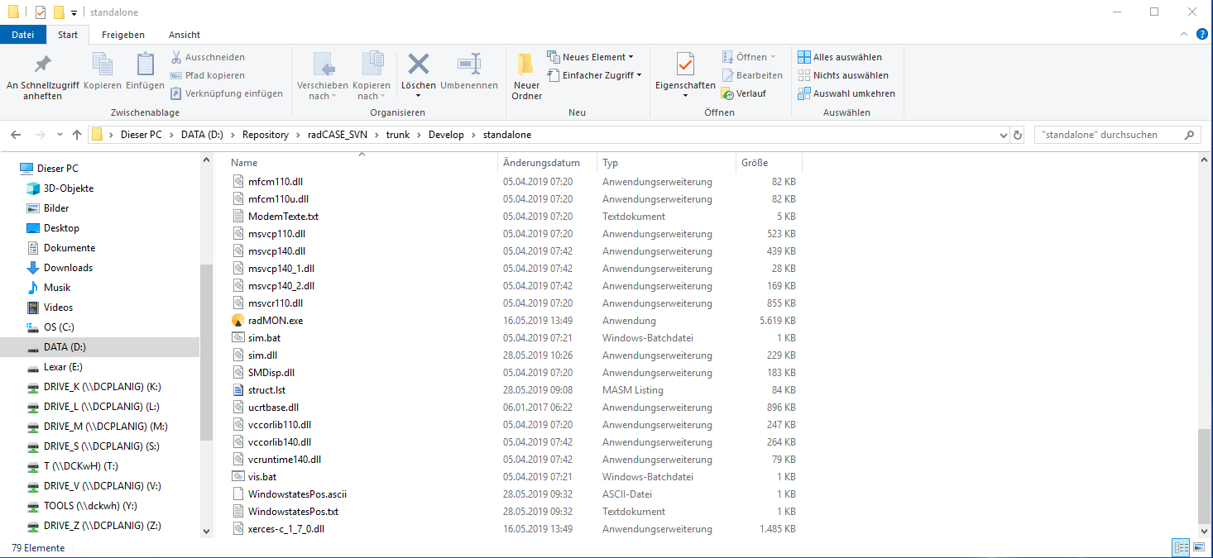

After execution radMON will open the Simulation or Visualisation. The appearing window could look like the following image (in this case the Visualization was opened).

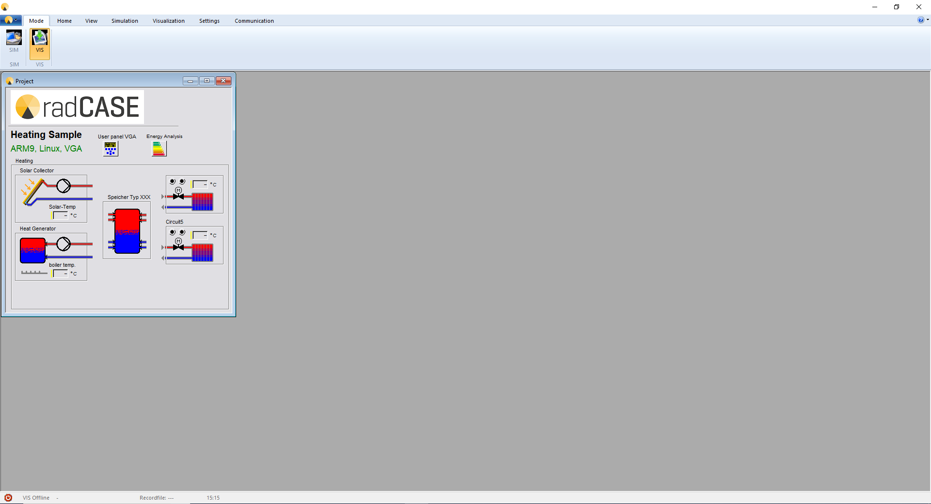

On the Top row you can see a menu ribbon bar which enables configuration of the monitoring environment. For detailed description refer to Menu Bar.

The “Project” window is the main screen of the Visualization and Simulation. From there you can open the user front panel which displays a window with the HMI interface (how it will be realised on the hardware). Refer to Remote Control for more information.

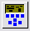

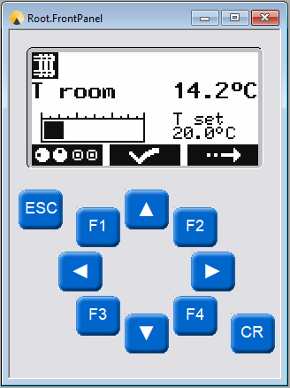

In the following chapter the Graphical environment will be explained more detailed.

# Graphical environment

|  |  |
| --- | --- |
|  | The following description of the graphical environment assumes using the standard ribbon bar and no customized ribbon bar,  where items could be changed/moved/hidden/greyed out |

## Status bar

The Status bar contains the following information:

* VIS Online/VIS Offline/SIM;
* record-file name;
* current System time;



Figure 4‑1, Status bar

The radCASE status bar is depicted inFigure 4‑1 and its fields are described hereafter.

### VIS Online/VIS Offline/SIM

This field shows if the Windows-Visualization is Online or Offline or if the Windows-Simulation is running:

|  |  |
| --- | --- |
|  | Visualization is online |
|  | Visualization is offline |
|  | Simulation is running |

|  |  |
| --- | --- |
|  | Note that there can be different reasons as the system is Offline:   * the cables are not connected correctly * the connection cable is broken * the communication port is not configured correctly. For this select the communication dialog in the menu and check the settings. Refer to Visualization. |

### Parameters in sync with target/changed on target

This field shows if the parameters on target are synchronized with the parameters displayed in Visualisation (since 4.12i, Rev. 9035 – see also 4.7.1).

### Record file

In this field it is displayed the name of the currently opened memory file.

### Time

The current system time is displayed here.

## Menu Bar



Figure 4‑2, Menu ribbon bar

Standardly you will see the shown ribbon bar displayed in Figure 4‑2, Menu ribbon bar. It is possible to adapt the ribbon bar to the users needs and wishes with a XML-script, refer to chapter 11.7.

Different program settings can be made with the Menu Bar. Furthermore it allows to change between different display types. Here is the list of the single menu options and their functions:

### File menu

The file menu deals with files used for database recording and playback – refer to chapter 4.11 for further details (except for the menu entry “Exit” which closes the radCASE Simulation and Visualization tool).

The file menu is activated by clicking on the round radCASE-Icon on the left side of the ribbon bar or by shortcut <Alt><F>.

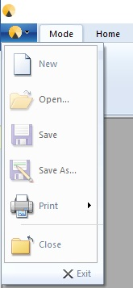

Figure 4‑3, file menu

|  |  |
| --- | --- |
| New | Opens a new record-file. If there is already an opened record file, it has to be saved or dropped. |
| Open | Opens an already existing record file. This is only possible if the Playback-Mode has activated. If there is already an opened record-file, it has to be saved or dropped. See Playback mode. |
| Save | Saves the current data in the currently activated record-file (refer also to 4.1.3), if any is currently opened. If no record-file has been opened, a dialog to define a record-file name will be opened. To use a customized record-file extension refer to 11.5.1. |
| Save as ... | Saves a record-file with a name that has to be indicated. To use a customized record-file extension refer to 11.5.1. |
| Print | See below, Printing functions. |
| Close | closes the currently activated record-file |
| Exit | Closes the program |

#### Printing functions

The functions always refer to the current active window. Every window can have a print surface. If the current window does not have a print surface the program communicates it.

|  |  |
| --- | --- |
| Print | Prints the displayed page. Use the graphical display to set the area for printing (see Graphical display of values). The defined area is automatically transferred in the print preview and then for the printing. |
| Print preview | Shows the page to be printed. Use the graphical display to set the area for printing (see Graphical display of values). The defined area is automatically transferred in the print preview and then for the printing. |

## Mode menu



Figure 4‑4, Mode menu

|  |  |
| --- | --- |
| SIM | Activates the Simulation and disables the current Visualization |
| VIS | Activates the Visualization and disables the current Simulation |

## Home menu

### Data

|  |  |
| --- | --- |
| ASCII-Export | Exports the recorded data of all ASCII-Export-Elements into a comma/semicolon separated file. For options and settings of this export refer to ASCII Export. |
| Sequence-Export | Exports only a sequence of the recorded data into a comma/semicolon separated file. For options and settings of this export refer to Sequence-export. |

### Language menu

|  |  |
| --- | --- |
| Language | Allows changing the language used by the Simulation/Visualization application. |

### Authorization menu

The Authorization menu allows setting passwords for different levels. According to these settings, some sections can be blocked for the lower levels. There are a total of 10 levels: 0 is the lowest and 9 is the highest password level.

|  |  |
| --- | --- |
| Authorize | Allows to type in a password to unlock a password level. If the entered password matches with any password level, this matching level and all lower levels will be unlocked. The access of sections with higher password levels will be still denied. |
| Lock | Locks the enabled password level again. |
| Passwords | It is possible to see all the passwords matching the current password level and lower password levels. Every listed password can be changed by double clicking on it. If any standard password has been ever changed, the new set will be saved in a file called “passwordlist.dat”. This file must be deleted to reset all the customized passwords. |

#### Default functions locked by a password

* The editing of an element can be blocked by a password (using the PL tag in the Format string).
* A password of at least level 5 is needed to activate the Force-Mode for the hardware outputs. This behaviour could be changed with the feature permissions (refer reference manual for more information’s).
* Some more features could be set with the feature permissions (see reference manual).

## View menu

The View menu allows to show or to close the different bars and windows. A tick symbolizes that the bars and windows have to be shown.

#### Zoom

|  |  |
| --- | --- |
| Zoom minus / plus |  |

#### View Windows

|  |  |
| --- | --- |
| View Status Bar | Activates or inactivates the Status Bar. |
| View Properties | Activates or inactivates the properties to display the Module Info and the Element Info of a Module that has marked in Module Tree |
| View Module Tree | Activates or inactivates the Module Tree |
| View Output | Activates or inactivates the Output window |
| Freeze Output | Freezes the output window. When freezed no more texts are added to the output. The texts are saved in the background and will be added, when unfreezing. |

#### View

|  |  |
| --- | --- |
| Record panel | Opens the window for the Record panel. See Record panel for details. |

#### Windows

The window display types can be set here. This menu allows activating a window from the opened ones. The activated window will come to the foreground.

|  |  |
| --- | --- |
| Cascade | Orders the windows from left top to right down. Only the Title bar is displayed for the underlying windows. |
| Tile Horizontal | Orders the windows horizontally in the main window side by side without overlapping. Every window has the same dimension and the space in the main window is completely used. |
| Tile Vertical | Orders the windows vertically in the main window side by side without overlapping. Every window has the same dimension and the space in the main window is completely used. |
| Windows… | If there are several module windows opened, it is possible to choose which one to be displayed at the front in this part of the drop-down menu. By clicking on “Windows…” a Dialog like shown below will be opened. |

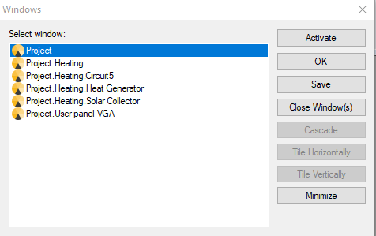

## Simulation menu

### RTC

|  |  |
| --- | --- |
| Simulated RTC | Allows to set date and time of the simulated control (see Figure 4‑5, Dialog “Simulated RTC”). These values can be set to the current values through the buttons **Act. Date** and **Act. Time**. |

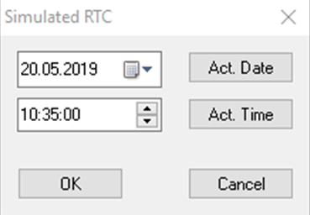

Figure 4‑5, Dialog “Simulated RTC”

### Time laps

It is possible to activate a time scale factor for the Simulation in order to run the process simulation in a quicker time. Possible factors are:

* 1x
* 5x
* 10x
* 25x

(Refer to Time laps and execution modes)

### Execution Mode

|  |  |
| --- | --- |
| Single Step Mode On | Activates or inactivates the single step mode. |
| Next Single Step | Executes next step. |
| Run/Stop Single Steps | Toggles between executing/stopping the next steps. |

(Refer to Single step mode)

### Sequences

|  |  |
| --- | --- |
| Open Sequence | Open a sequence for processing |
| Process Sequence | Activate execution of open sequence |
| Close Sequence | Closes the open sequence |

(Refer to Sequence processing)

## Visualization menu

### Run

|  |  |
| --- | --- |
| Force Mode | Activates or deactivates the Visualization internal Force mode. When the Force mode is activated it is possible to force individually digital and analogue outputs or inputs of the target system by clicking the icons in the Visualization. This means that the respective Input/Output is divided from the target process and allocated with a “fixed value“.  When the Force mode is inactive, all the forced outputs are enabled i.e. connected with the respective process. |
| Automatic update of parameters | The visualization will detect if parameters are changed on the target and will display this in the status bar. If this new feature “automatic parameter update” is activated, the visualization will automatically call “Parameters from device” when the parameters are changed.  Previous behaviour (up to 4.12i, Rev. 9034): When a parameter was changed from visualization the visualization would wait for the time specified in Timings dialog “Parameter update”. After that time “Parameters from device” would be called automatically. This only worked as long as the parameters were changed from visualization and not from the target. The new feature replaces this, so the old setting is not needed anymore. The new feature supports detecting changes of parameters regardless if they were triggered from visualization or directly on target. |

### Online

|  |  |
| --- | --- |
| Receive mode | Activates the record/receive mode and deactivates the playback mode (refer to Record mode). |
| Playback mode | Activates the playback mode and deactivates the record/receive mode (refer to Playback mode). |
| Burst mode | Activates or inactivates the Burst transfer mode (refer to Record mode). |

## Settings menu

### Settings

|  |  |
| --- | --- |
| Select Communication Interface | Select the interface used for communication. The communication is done through a plugin DLL. These can be added and removed to the project monitor, to allow communication over all supported communication channels of the target controller. The option opens a dialog box to select the plugin DLL identified by a name provided by the DLL. |
| Configure Communication Interface | Configures the currently selected communication interface. The configuration is DLL specific and is provided by the DLL. The configuration contains further information to establish a connection for a communication channel, e.g. Com-Port and Baudrate for a serial interface or IP-address for an Ethernet connection. |
| Recording Settings | Opens a dialog box with the settings for recording of data and automatic saving of those recordings. Refer to Recording *.* |
| Event notifier | Opens a dialog box with the settings for notification on special events. Refer to Event notification*.* |
| Timing | Opens an input dialog to set different time values (see Figure 4‑6). For more information’s refer to reference manual chapter 4.8.2 (Language Reference – Settings – Timing). |

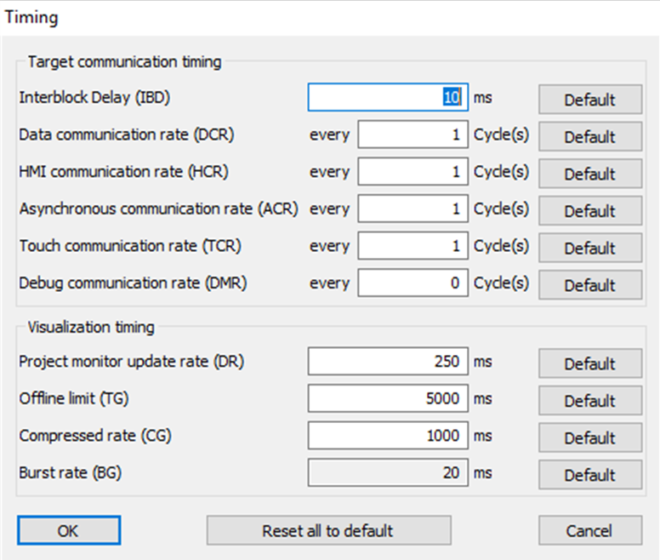

Figure 4‑6, Timing dialog (since 4.12i, Rev.9472)

## Communication menu

The Communication menu is used during Visualization to control the communication between the Visualization application and the controller. It offers the following commands:

|  |  |
| --- | --- |
| **Parameters from device** | Loads application parameters PAR and/or SYS from the controller device to the Visualization application. This will be done automatically if a parameter on the controller has changed and if this option has not been explicitly disabled (see also 4.7.1 “Automatic update of parameters” since 4.12i, Rev. 9034 ) |
| **Parameters to device** | Sends the application parameters PAR and/or SYS from the Visualization to the controller device and stores them to the persistent storage. Note that before those parameters are send to the application, they must be loaded with **Load parameters** command. |
| **Load parameters** | Loads (not send) parameters PAR from the hard disk to the Visualization application on choosing a *.par-file. Also on choosing a XML-file the parameters PAR will be loaded but not send to the controller. On loading parameters via XML-file and desktop setting SE (refer to reference manual) is set, the SYS will be loaded and send to controller. On loading parameters via XML-file and desktop setting PRE (refer to reference manual) is set, the PROC will be loaded and send to controller. Each transmitted parameter is stored on the persistent storage of the controller. |
| **Save parameters** | Saves parameters PAR from the Visualization application to the hard disk drive into a XML-file. If desktop setting SE (refer to reference manual) is set, also the SYS is saved into that file and if desktop setting PRE (refer to reference manual) is set, also the PROC is saved. |
| **Parameters to ASCII** | Saves the parameters PAR in an ASCII text format. See section ASCII Export for details. If desktop setting SE (refer to reference manual) is set, also the SYS is saved into that ASCII file. |
| **File transfer** | Opens a dialog which makes it possible to transfer files from the computer to the target device or from target to computer (refer to 4.16). |
| **Transfer recording** | Opens a dialog which makes it possible to transfer a recording made with recording.rad from the target to the computer. (refer to Transfer recording) |
| **Modem connection** | Opens the modem connection dialog, where the settings for a modem connection can be set. Further information about the parameter settings for the modem is given in section Serial connection |

The following table shows, which groups of the persistent data (SYS, PAR, PROC) are affected by which commands:

|  |  |  |  |
| --- | --- | --- | --- |
| Command | SYS | PAR | PROC |
| Parameters from device | Yes | Yes | No |
| Parameters to device | Yes(1) | Yes(1) | No |
| Load parameters (via *.par-file) | No | Yes | No |
| Load parameters (via *.XML-file) | If SE=1 (1) | Yes | If PRE=1 (1) |
| Save parameters | If SE=1 | Yes | If PRE=1 |
| Parameters to ASCII | If SE=1 | Yes | No |

Table 5, command affected groups; (1) the persistent data is not only transferred but will also be written to the persistent storage of the target.

## ? menu

|  |  |
| --- | --- |
| Help Topics | List help topics (refer to 11.9) |
| About CommonRADCase… | Display program information, version and copyright |

## Record panel

The record panel is used to control the recording and playback of Simulation and Visualization sessions. You can open the Record Panel in the View menu. If the application is in the Record mode, the signal values are recorded. In Playback mode the application runs a playback session of the recorded data. The recording can also be saved to a set of files and be loaded for later playback – see chapter 4.2.1.

The following features are available:

* Record
* Playback
* Save recording to a record-file
  + Automatic saving
* Open a record-file for playback
  + File menu
  + Drag on SIM/VISU and drop
  + Start SIM/VISU from command line with specified record-file

### Record mode

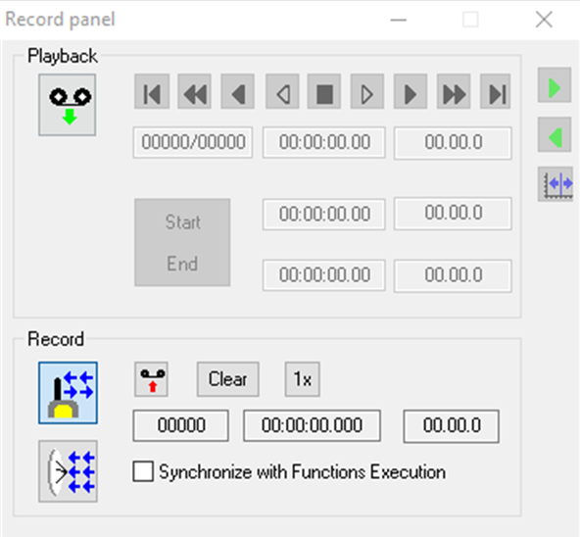

Figure 4‑7, Record panel in Record mode

Starting from the left the following data are displayed in the Record panel when is activated the Record mode (see Figure 4‑7):

* number of the current record
* time of the current registered record
* Date/Timestamp of the current record

|  |  |
| --- | --- |
|  | Activates the Record mode. The communication between the recorder and the controller is established but the recording is not started. |
|  | Enables the Burst transfer mode. In the normal transfer mode, a handshake protocol is used for the communication between controller and Visualization. In the Burst transfer mode, the handshaking is omitted and the data is transmitted in a higher speed from the controller device. |
|  | Starts or stops the recording. The record mode needs to be activated before this command can be executed. |
|  | Deletes the recorded data. |
|  | Records one single record. |

### Playback mode

The following information´s are displayed in this order when the Playback mode in the Record panel (see Figure 4‑8) is activated:

* number of the registered record / total records
* time of the registered record
* date of the registered record

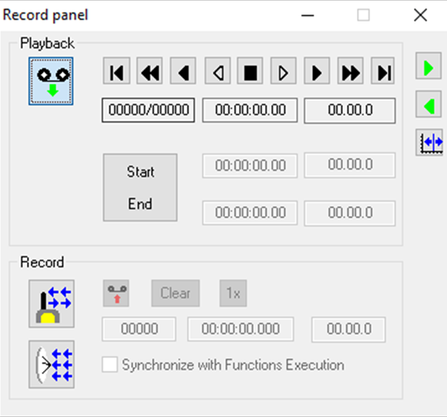

Figure 4‑8, Record panel in Playback mode

By clicking on one of the numerical information fields, the playback Record selector dialog box is opened (see Figure 4‑9).

This dialog box is used to set the cursor in the graphical display to the selected record number. See section Graphical display of values for details.

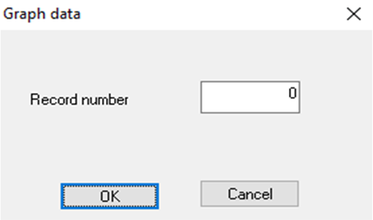

Figure 4‑9, Record selector dialog

The following buttons on the Record panel can be used during the Playback mode:

|  |  |
| --- | --- |
|  | Activates the Playback mode. The activation is also possible through the symbol bar. |
|  | Moves the Playback position to the first record. |
|  | Moves the Playback position 100 records backwards. |
|  | Moves the Playback position 10 records backwards. |
|  | Moves the Playback position 1 record backwards. |
|  | Stops playing. |
|  | Moves the Playback position 1 record forwards. |
|  | Moves the Playback position 10 records forwards. |
|  | Moves the Playback position 100 records forwards. |
|  | Goes to the last record. |
|  | Starts playing forward. |
|  | Starts playing backwards. |
|  | Controls the position of the cursor in the graphical display. If this option is set, then the cursor is fixed at left side of the graph and the curve will be updated accordingly. If the option is not set, then the curve for the value is fixed and cursor will be updated according to the simulated time during playback. See also section Graphical display of values |

### Record Panel Feature Notes

#### Record

For more detailed descriptions about this panel refer to 4.11.1.

Too manually start or stop the recording activate the record mode and click on the  button.

#### Playback

To open a record-file for playback click on “Open…” in the file menu, described on 4.2.1. The currently opened record-file can be seen at the status bar (refer to 4.1.3). Now the playback buttons described on 4.11.2 can be used.

#### Save recording to a record-file

* Manually:

At first some recording data must be recorded before (refer to 4.11.3.1).To save the recording into a record-file use the “Save” or “Save as…” buttons described on 4.2.1. To customize the name or extension of the record-file refer to 11.5.1.

* Automatically: refer to 4.14.1 and 4.14.5

#### Open a record-file for playback

* File menu (refer to 4.2.1):
* Drag on SIM/VISU and drop:
  + Playback mode must be activated before (refer to 4.11.2)
  + Simply drag and drop the record-file (*.rdf-file or with customized extension, refer to 11.5.1) on to the SIM/VISU surface. The actual loaded file can be seen at the status bar (refer to 4.1.3).
* Start SIM/VISU from command line with specified record-file
  + Refer to 8.4 to start the SIM/VIS via command line
  + Use the command line parameter “/REC_FILE” to open a record-file (refer to 8.5)
  + Example: “sim.bat /REC_FILE=C:\Temp\CusExtension\foo.xyz” will start the simulation with a defined record-file foo.xyz. To use a customized record-file extension refer to 11.5.1. The actual loaded file can be seen at the status bar (refer to 4.1.3).

## Main window

The main window is the representation of the project process. The process view can be also displayed in different hierarchical windows, depending on the application.

.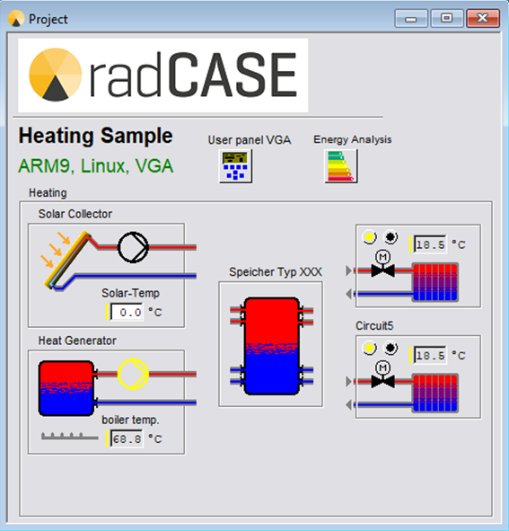

Figure 4‑10, Main window

radCASE uses several different styles to display the type and state of values.

Colored bars are used to indicate the type of the value. Table 6explains the usage of the colors in relationship with Elements types.

|  |  |  |  |
| --- | --- | --- | --- |
| **Colour** | **Display** | **Element type** | **Description** |
| Magenta |  | PROC | Process Variable |
| Yellow |  | AI, AO, DI, DO, CNT | Inputs and outputs |
| Blue |  | PAR | Parameter |
| Blue/White |  | SYS | System Parameter |

Table 6, Bars colours used to display Elements type

The background color is used to indicate the status of the value. The backgrounds showed in Table 7are used to distinguish between editable and non-editable values.

|  |  |
| --- | --- |
| **Display** | **Description** |
|  | Editable value |
|  | Non-editable value |

Table 7, Display of editable values

The following images with red backgrounds (seeTable 8) are used to indicate out of range and alarm conditions.

|  |  |
| --- | --- |
| **Display** | **Description** |
|  | Value out of range (overflow) |
|  | Value out of range (underflow) |
|  | Alarm condition |

Table 8, Display of alarm conditions

Table 9 shows the examples of the additional display options.

|  |  |
| --- | --- |
| **Display** | **Description** |
|  | Editable value with a toggle editor |
|  | Value with description (“T = “) and unit (“s”) |

Table 9, Display options

There are also special values that can be displayed in combination with this. The NoValue (refer to Reference Manual) is shown as “-“. An element which is not communicated (refer to Reference Manual for ComType V0) is shown with a value of “X”.

## Graphical display of values

In order to display values in a histogram, a surface with a **Melem** (see **Reference Manual**) has to be included in the radCASE Design. This surface should have an **ICON**, whichopens in the Visualization or in the Simulation the following window:



Figure 4‑11, Value histogram

The following information is displayed:

* The legend directly above the graphic shows the colour attribution to the value names.
* The current zoom factors are shown right above the graphic. “Y-Zoom = x1“ means that the y-axis is displayed with one fold magnification. The “x” has to be read as multiplication factor.

The following actions can be executed:

|  |  |
| --- | --- |
|  | Extends/Minimizes the resolution in the respective time axis |
|  | Extends/Minimizes the resolution in the respective value axis |
|  | Opens an Info box to the value type whose scale is visible in this moment (this Info box contains for value types with finite numerous states also an explanation for these states) |

|  |  |
| --- | --- |
|  | During the time axis scrolling the playback mode of the registration panel has to be used (see Playback mode), because the illustration is chronologically connected with the current data record. This is marked in the graphic by a cursor (vertical black bar). |

## Recording options

There are several options that can be set for recording data using the menu Setting **>** Recording settings. The dialog box that appears is divided into five sections:

* Database
* ASCII-Export
* Sequence-export
* General export setting
* Recording

### Database

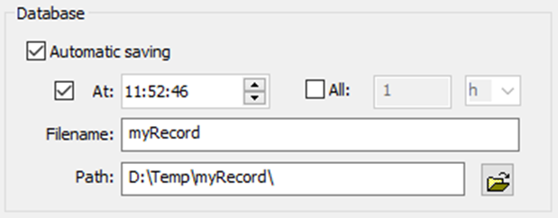

Figure 4‑12, Record-Settings-Database

By enabling Automatic saving (see Figure 4‑12, Record-Settings-Database) the recorded database is saved into a record-file, when the maximum number of records (**Desktop** setting **MR,** refer to Reference Manual) is reached. It is also possible to specify a time interval to trigger the saving.

If the automatic saving is enabled the following options are available:

|  |  |
| --- | --- |
| **At** | Time at which the automatic saving is triggered, if enabled. If not specified otherwise the recorded data is saved daily at the specified time. |
| **All** | Time interval for the data saving, if enabled.  The saving interval can be changed for example from daily to every hour or weekly. If an interval is specified, the first saving will be done at the first possible time where a following interval will match the time specified in At.  I.e. if it is entered **At**: 10:30 **All:** 2h and it is 9:20 the first saving will be 10:30 but if it is 7:20 the first saving will be 8:30, because after the next interval it will be 10:30 which is specified as start time. |
| **Filename** | The filename used to save the database without extension (*.rdf or any other customized extension will be added automatically). The filename can be composed also by variables, which will be replaced automatically:  %T: Will be replaced by the time of saving in the format HHMM.  %D: Will be replaced by the data of saving in the format YYMMDD.  Note that existing record-files will be replaced without asking. So if any variable is used, there will be only one record-file with the last saved data. |
| **Path** | Path where to save the record-files. The Icon at the end of that line allows choosing a path. |

|  |  |
| --- | --- |
|  | Every time the automatic saving is triggered the current database will be emptied after saving. |

If **Automatic saving** is disabled and the recorded database has reached the maximum number of records, recording is stopped and the following dialog box appears:

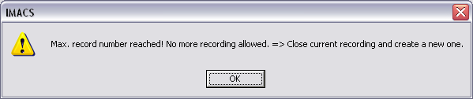

Figure 4‑13, Error message for maximum data records reached with Automatic Saving disabled

### ASCII Export

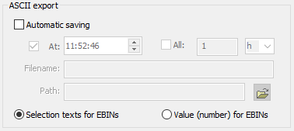

Figure 4‑14, Record Settings – ASCII export

ASCII Export (see Figure 4‑14) has the same option for Automatic saving described in section Database. When Automatic saving is triggered a comma/semicolon separated file is created including the recorded data of all elements marked for ASCII-export with ComType X<#> (refer to Reference Manual for further details). The current database will be emptied only if no automatic saving is active for the database.

Additional options:

* The values of exported EBINs can be shown as digital values or as the selection texts of that EBIN (recommended in most cases).
* Refer to General export settings

After every ASCII-export the external file *export_post.bat* in the DEVELOP-directory is called, where further automatic processing of the exported CSV-File can be performed. The export_post.bat will get two arguments:

1. The filename including the path of the exported file. This is especially needed if the filename uses variables.
2. If the file is comma or semicolon separated (refer to General export settings).

### Sequence-export

This option allows exporting the values of specified ELEMNTSs at different times of the recorded data.

|  |  |
| --- | --- |
| **All elements** | The sequence will contain all ELEMENTs of the project |
| **Selection** | The sequence will contain only the selected ELEMENTs that has been specified before (ComType S<#>; refer to Reference Manual) in the design. |
| **Always** | The selection of ELEMENTs will be exported every time even if the value has not been changed. |
| **Only on change** | The selection of ELEMENTs will only be exported if it´s value had changed. |

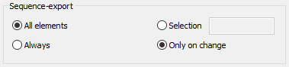

Figure 4‑15, Record Settings – Sequence Export

### General export settings

It is possible to choose between a commas separated file (needed for most Excel-versions) or a semicolons separated file (needed in German Excel-version). If set correctly, the generated CSV-file can be opened directly in Excel.

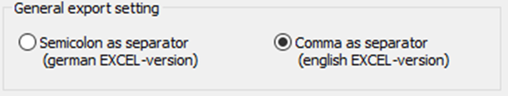

Figure 4‑16, Record Settings – General export settings

### Recording

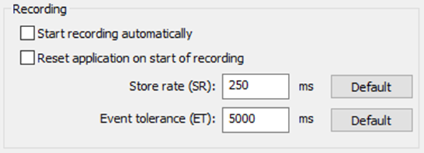

Figure 4‑17, Record Settings – Recording

In this section (see Figure 4‑17) there are general options for the data recording:

|  |  |
| --- | --- |
| **Start recording automatically** | The data recording is started automatically as soon as the Visualization goes Online, the Simulation is started or an automatic saving is triggered. Because the recording isn’t normally stopped when automatic saving is triggered, this only affects the cases where the user manually stops the running recording, or an error occurs and the recording is stopped (i.e. maximum amount of data recorded refer to desktop setting **MR=** described in Reference manual). |
| **Reset application on start of recording** | The application will reset on start of recording. |
| **Store rate** | The interval in which a dataset is recorded. |
| **Event tolerance** | The maximum time between to datasets to display the data as continuous graph. If this time is exceeded there will be a gap in the graph surrounded by rectangles to even see little gaps. The same behaviour of the graph can occur if the Offline limit is exceeded. |

## Event notification

By calling the menu Settings **>** Event notifier a dialog box (see Figure 4‑18) that allows to set up the event notification.

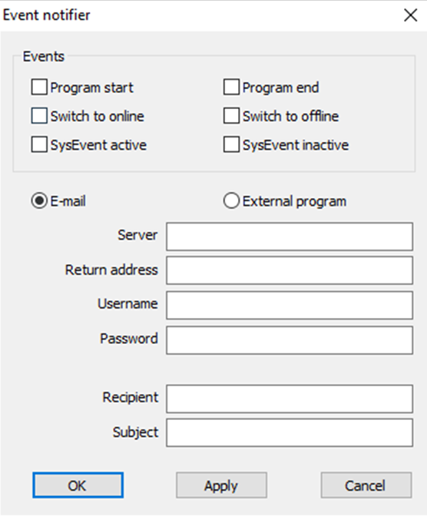

Figure 4‑18, Event notifier

The Events section allows to choose on which events the event notifier should trigger. It can trigger on starting and ending of the program, on changing of the Visualization to Online or Offline mode (note that Simulation is always online so it will only trigger “Switch to Online” at start of the program).

Lastly it can trigger on SysEvent variables set in the design. SysEvent active will trigger every time one of the SysEvent variables changes its value to a value different than zero. The SysEvent inactive event will trigger when one of the SysEvent variables will change its value to zero.

When one of these two events is triggered a list of the current values of XE-marked-elements is added in the text file (refer below). For further explanations of SysEvent variables and XE-elements refer to the reference manual.

When an event is triggered the text file “event.txt” is generated in the DEVELOP-directory. The created text can be changed by modifying the “Mail.txt” in the according Common directory. At the end of the file a list of the current values of the XE-elements is added. For each element a line (separated by *\n*) is created in the following format:

*<Element description>:\t<element value>*

or if a unit is specified:

*<Element description>:\t<element value> [<unit>]*

When enabling event notification by enabling an event trigger it is required to choose what action will be taken when the event is triggered. It can send an E-Mail or call an external program.

The E-Mail service needs the following information:

|  |  |
| --- | --- |
| **Server** | Address of the email server used to send the mail, like smtp.mailserver.de or localhost or 192.168.0.1.  Note that it is not possible to send mails using a server that only allows secure connection. |
| **Return address** | The address that is provided as sender address of the mail. |
| **Username** | Username needed to login into mail server. |
| **Password** | Password needed to login into mail server (if no password is needed may be left empty). |
| **Recipient** | Mail address the mail should be sent to. Can be multiple mail addresses by separating the mail addresses with comma (in this case enclose everything in quote signs: “recipient1@mailserver.com, receipient2@mailserver.com”. |
| **Subject** | The subject for the e-mail. |

The generated text file will be used as text of the e-mail.

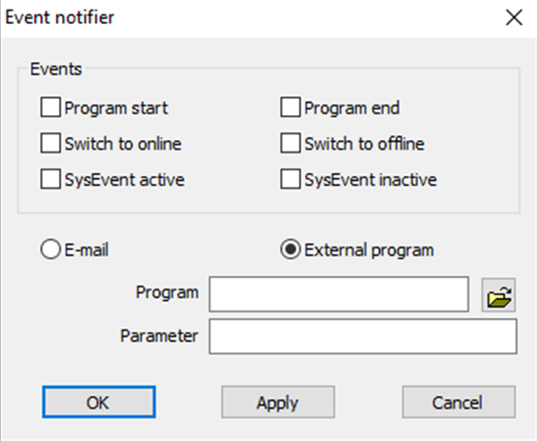

Figure 4‑19, Event notifer – External program

When the option for calling an external program is chosen (see Figure 4‑19), a program to call has to be selected (also by using the icon at the end of the line). If the program needs parameters they must be provided them in the **Argument** line.

E.g. with this option it is possible to call a program which evaluates the event.txt and executes further actions.

## File transfer

Calling this command will open the following dialog:

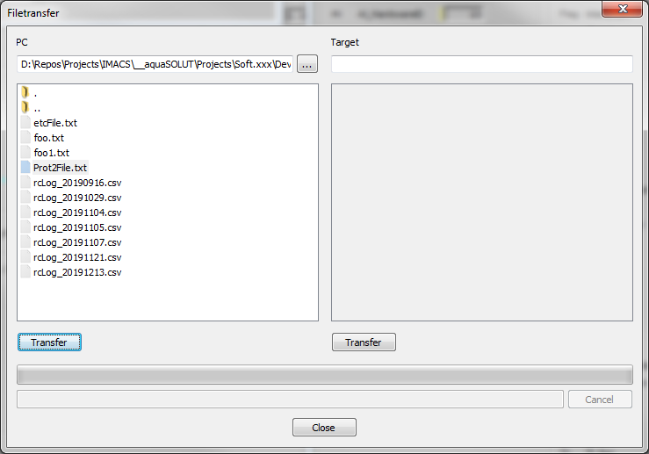

Figure 4‑20, File transfer dialog

Like described in that dialog, the left side represents the PC side and the right side represents the Target side. It is possible:

* To transfer a single file from any directory of PC to the root directory of the Target’s SD-Card
* To transfer a single file from any directory of Target’s SD-Card to any directory on the PC

|  |  |
| --- | --- |
|  | Note that it is not possible to transfer a file into any subdirectory of the Target’s SD-Card. |

### Transfer file from PC to Target

On the left side of file transfer dialog browse into the correct directory and select the file, which should be copied to the SD-Card. Clicking the left Transfer-Button will start copying this file to the root directory of the SD-Card. If this file already exists, a dialog will appear:

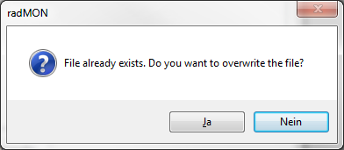

Figure 4‑21, overwrite confirm dialog

### Transfer file from Target to PC

On the right side of file transfer dialog, the full name of the source file must be typed in. Clicking the right Transfer-Button will start copying this file to the currently selected directory of the left PC side. If copying was successfully, the file is listed on the left side. If this file already exists, a dialog will appear (see Figure 4‑21, overwrite confirm dialog).

The source file on the Target’s SD-Card can be copied from any subdirectory. In case of not copying from SD-Card’s root directory, the full name and path must be typed in. The following shows an example:

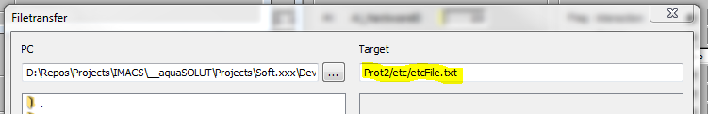

Figure 4‑22, example of full path

## Transfer recording

The command allows to transfer recordings made with recording.rad to the computer.

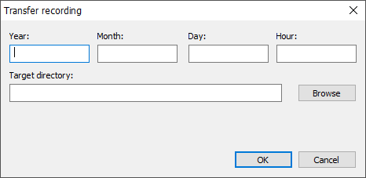

The file structure from target will be mirrored to the target directory. If the target directory does not exist, the directory will be created. Within the target directory wildcards can be used, to create different directories depending on the time of transfer:

|  |  |
| --- | --- |
| %a | Abbreviated weekday name in the locale |
| %A | Full weekday name in the locale |
| %b | Abbreviated month name in the locale |
| %B | Full month name in the locale |
| %c | Date and time representation appropriate for locale |
| %C | The year divided by 100 and truncated to an integer, as a decimal number (00−99) |
| %d | Day of month as a decimal number (01 - 31) |
| %D | Equivalent to %m/%d/%y |
| %e | Day of month as a decimal number (1 - 31), where single digits are preceded by a space |
| %F | Equivalent to %Y-%m-%d |
| %g | The last 2 digits of the ISO 8601 week-based year as a decimal number (00 - 99) |
| %G | The ISO 8601 week-based year as a decimal number |
| %h | Abbreviated month name (equivalent to %b) |
| %H | Hour in 24-hour format (00 - 23) |
| %I | Hour in 12-hour format (01 - 12) |
| %j | Day of the year as a decimal number (001 - 366) |
| %m | Month as a decimal number (01 - 12) |
| %M | Minute as a decimal number (00 - 59) |
| %p | The locale's A.M./P.M. indicator for 12-hour clock |
| %r | The locale's 12-hour clock time |
| %R | Equivalent to %H:%M |
| %S | Second as a decimal number (00 - 59) |
| %t | A horizontal tab character (\t) |
| %T | Equivalent to %H:%M:%S, the ISO 8601 time format |
| %u | ISO 8601 weekday as a decimal number (1 - 7; Monday is 1) |
| %U | Week number of the year as a decimal number (00 - 53), where the first Sunday is the first day of week 1 |
| %V | ISO 8601 week number as a decimal number (00 - 53) |
| %w | Weekday as a decimal number (0 - 6; Sunday is 0) |
| %W | Week number of the year as a decimal number (00 - 53), where the first Monday is the first day of week 1 |
| %x | Date representation for the locale |
| %X | Time representation for the locale |
| %y | Year without century, as decimal number (00 - 99) |
| %Y | Year with century, as decimal number |
| %z | The offset from UTC in ISO 8601 format; no characters if time zone is unknown |
| %Z | Either the locale's time-zone name or time zone abbreviation, depending on registry settings; no characters if time zone is unknown |
| %% | Percent sign |

The input fields Year, Month, Day and Hour can be used to limit the files transferred. If nothing is specified all recordings on the target are transferred. The resolution used on the target to store recordings can’t be exceeded. Finer details will be ignored.

E.g. if the target stores recordings with a recording range of 1 month, the selected day and hour will be ignored and all recordings from the selected month are transferred.

|  |  |
| --- | --- |
|  | The resolution of the target is detected by file structure. If changing the recording range on the target, any leftover files in the recording directory could lead to a false detection. |

# Visualization

This section deals with the commands, operations and settings used by the Visualization. It explains how to setup a connection between the Visualization application and the controller device. If a password is set up on the controller, a password dialog will be displayed during the connection establishment. For a modem connection the password dialog contains the controller identification.

## Serial connection

To ensure connection over USB it is necessary to use a USB program adapter which connects to the PC USB Port and the 4-pin connector on your target PCB. The 4-pin connector port should look like shown in the following picture.

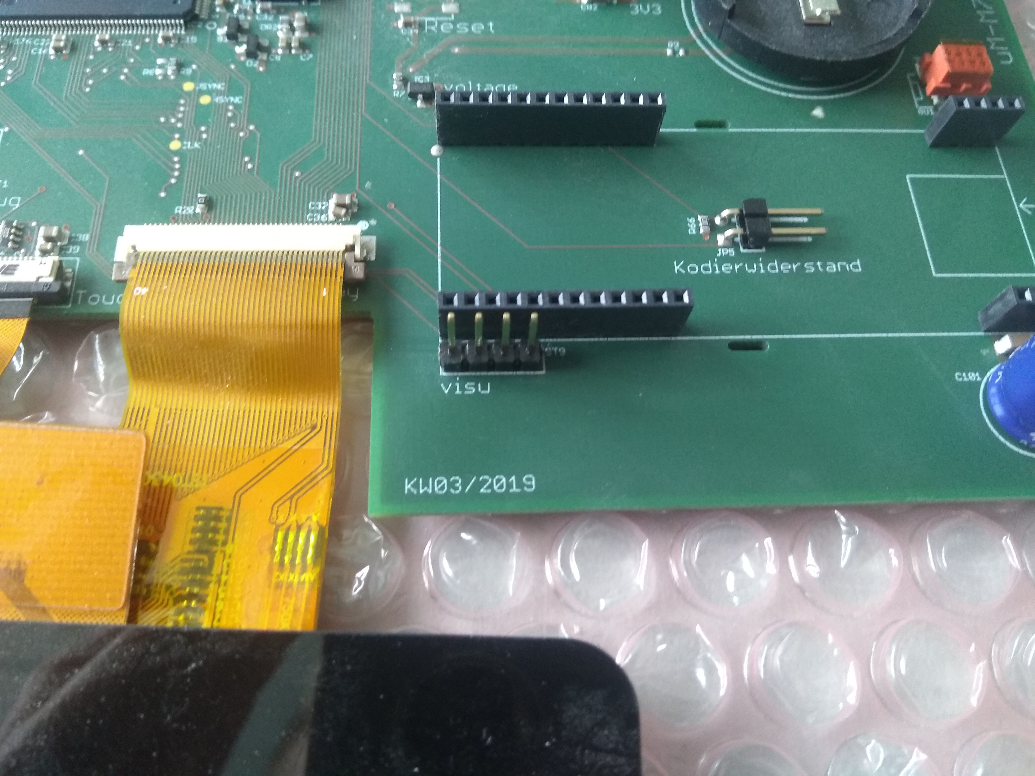

The power supply should be shut down while setting up connection. In the Visualization under

**Settings** **menu** / **settings** / **select communication interface** the **“**serial” connection has to be chosen. After that the COM port needs to be configured in the **Settings** **menu** / **settings** / **configure communication interface**. If the COM port is unknown the Windows Device Manager can give insight were the USB adapter is connected to. When configuration was successful the Visualization should go online with starting the application on the hardware (see VIS Online/VIS Offline/SIM).

## Ethernet/ TCP-IP connection

Establishing connection via Ethernet is rather easy. After connecting the PC Ethernet Port with the target PCB and choosing Ethernet connection in **Settings** **menu** / **settings** / **select communication interface**, the IP-Address of the controller needs to be configured in **configure communication interface**. When configuration was successful the Visualization should go online with starting the application on the hardware (see VIS Online/VIS Offline/SIM).

## Modem connection

For those cases where a modem connection is used as communication means between Visualization and controller, the settings for the modem must be set in the Visualization application. The modem connection dialog is opened with the command **Modem connection** (see Figure 5‑1) from the **Communication** menu.

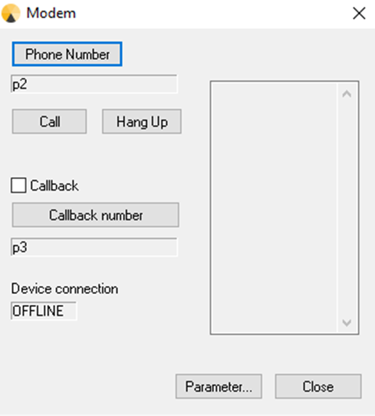

Figure 5‑1, Modem connection

The following information’s are displayed:

* phone number
* recall number
* device connection
* parameter
* state
* communication Interface

### Modem directory

By clicking on **Telephone number** (see Figure 5‑2) a new window is opened where the phone numbers can be inserted, modified and deleted (see Figure 5‑3). Moreover, the dialing mode can be selected as pulse or tone. The selected phone number is memorized by confirming with **OK** for the next call.

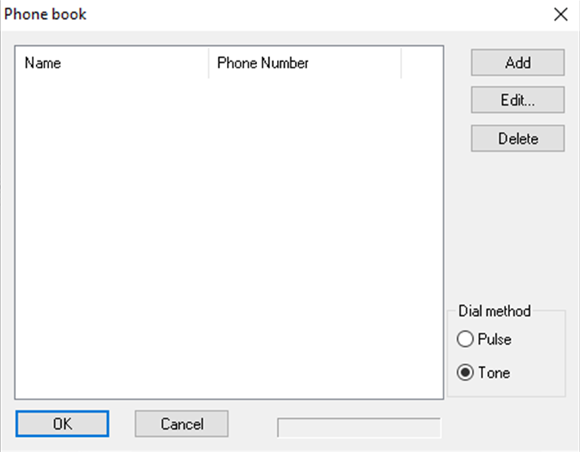

Figure 5‑2, Selection window to add and modify the phone number

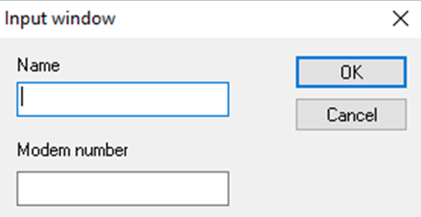

Figure 5‑3, Input window for name and modem number

By clicking the button **Callback number** the phone number of the modem can be inserted and decided whether it should be called back using tone or pulse dialing (see Figure 5‑4). The call back is only executed if it is activated in the selection field **Callback**.

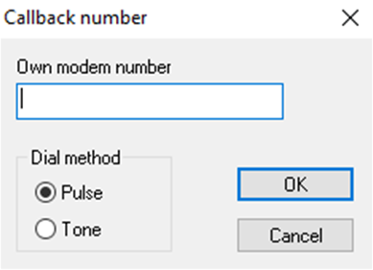

Figure 5‑4, Call-back number Dialog

### Connection establishment

By clicking the **Call** button a connection to the inserted phone number is started.

In case of a successful connection establishment “ONLINE“ appears in the device connection field. If the recall option has been selected before, the modem hangs up after a successful connection establishment and is then called back by the modem of the remote station. The successful connection is shown by “ONLINE” in the device connection field.

|  |  |
| --- | --- |
|  | Do not forget to close the connection after hanging up for terminating the connection. |

### Communication parameter

By clicking the button **Parameter** a window is opened (see Figure 5‑5) for the modem selection parameters. Please read the possible parameters of the modem in its user manual.

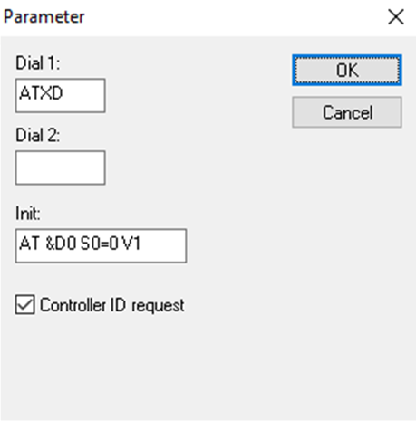

Figure 5‑5, Modem parameter

The connection is terminated by clicking the **Hang up** button. This is indicated by “OFFLINE” in the device connection field.

Pay attention that the correct interface has been selected. It is shown in the right corner above the status window. To modify the interface, close the modem connection window and select the desired interface in the menu item interface settings (seeSettings*)*.

## Remote Control

### General information

In order to use the remote control, a communication connection between PC and controller has to be established (see Serial connection, Ethernet/ TCP-IP connection, Creation of a modem communication). Also the **user front window** has to be activated through the following icon in the main window (project window) inside the Visualization. This function is optional.

|  |  |
| --- | --- |
|  | Opens the user front window. |

### The user front window in Offline mode

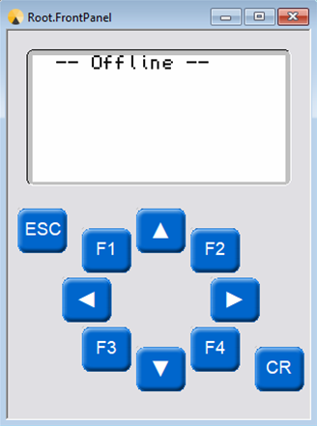

Figure 5‑6, User front window in the Offline mode

If the user front window is opened without a connection to the controller, the writing “Offline“ is shown in the Visualized display (see Figure 5‑6).

### The user front window in the online mode

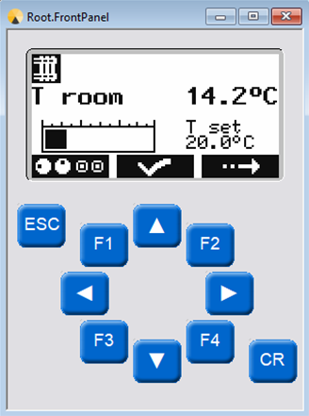

Figure 5‑7, User front window in the Online mode

In the Online mode the user front display is the same of the user front of the controller. Also the button functions are analogue, i.e. the visualized arrow keys as well as <ESC> and <Enter> keys can be used by a mouse click or through the PC keyboard.

|  |  |
| --- | --- |
|  | After using a key on the visualized remote control, the key input on the controller is blocked for about 10 seconds. |

## Connection errors

While establishing the connection radCASE checks if the target software matches the Visualization. The following errors may occur if the software does not match the Visualization:

|  |  |
| --- | --- |
| **Error-Message** | **Description** |
| **Wrong size of parameter data.** | The size of the parameters is different between target and Visualization. This normally happens because of a new or deleted parameter or because of a changed data type. |
| **Wrong version of parameter data.** | The version set by the Define VERS_PARAM is different between target and Visualization. |
| **Wrong device ID of parameter data.** | The version set by the Define DEVICE_ID is different between target and Visualization. |
| **The software versions of target und Visualization do not match.** | The version of the software set in Systemdef->Version is different between target and Visualization. |
| **The versions of calibration data structure of target and Visualization do not match.** | The version set by the Define VERS_KALI is different between target and Visualization. |
| **The versions of the system data structures of target und Visualization do not match.** | The version set by the Define VERS_SYSTEM is different between target and Visualization. |
| **The versions of process data structures of target und Visualization do not match.** | The version set by the Define VERS_PROC is different between target and Visualization. |

Table 10, Connection errors

In all of these cases the Visualization will continue working and try to assign the data provided by the target with the data of the design.

# Simulation

## Time laps and execution modes

It is possible to activate a time scale factor for the Simulation in order to run the process simulation in a quicker time. This can be chosen in menu **Simulation 🡪 Time laps**. The following values are possible:

|  |  |
| --- | --- |
| **1x** | Normal execution speed, i.e. 1 second in the Simulation corresponds to 1 second in the normal device. |
| **5x** | 5 fold execution speed, i.e. 1 second in the Simulation corresponds to 5 seconds in the normal device. |
| **10x** | 10 fold execution speed, i.e. 1 second in the Simulation corresponds to 10 seconds in the normal device. |
| **25x** | 25 fold execution speed, i.e. 1 second in the Simulation corresponds to 25 seconds in the normal device. |

## Single step mode

In single step mode the perm task, the inter task and the surface interpreter task are synchronized. A single step will perform the following steps:

* Check for a sequence with the right timestamp, set the according values to the elements and increase the internal timer (only if a sequence is selected; refer to Sequence processing)
* One run through all of the tasks, in the order Inter task, Perm task, Surface interpreter task.
* Receive values from the simulated target
* Send values to external tool (if an external tool is connected; refer to Using ITC Interface (Inter Tool Communication))

|  |  |
| --- | --- |
|  | The surface interpreter task is not fully supported. Entering loops in the surface interpreter task (e.g. standard edit dialogs) will cause a deadlock. |

When activating the single step mode using Simulation 🡪 Execution Mode 🡪 Single Step Mode On the simulation will go into a paused state. In this state single steps can be executed by selecting Simulation 🡪 Execution Mode 🡪 Next Single Step. When selecting Simulation 🡪 Execution Mode 🡪 Run/Stop Single Steps the single steps will be executed without pause between the steps. This mode is mainly useful when combined with Sequence processing and/or Using ITC Interface (Inter Tool Communication)

## Sequence processing

Sequence processing is a way, to feed a sequence of element value changes into the simulation to be executed on specific times. The sequence processing is only supported in conjunction with the Single step mode.

With Simulation 🡪 Sequences 🡪 Open Seqeunce a sequence can be loaded into the simulation. The sequencer supports two file formats:

1. A CSV-file which can be generated with Excel. The CSV file need to have the following columns: <Timestamp>,<element name>,<value>,<command>
2. A txt-File in the format: <Timestamp> <element name> <value> <element name> <value> ...

The Timestamp has to be in the format seconds.centiseconds (e.g. 1.3).

The Elementname has to be the full path to the element as specified in struct.lst. The value has to be in the internal format of radCASE as it is contained in the underlying C-variables.

Currently the only supported command is “EndSequence”. Every line following the EndSequence command is considered a new sequence. In a txt-File an empty line is considered as separator for a new sequence (the timestamp for that new sequence would be the next step after the last timestamp in the sequence). When reaching the time stamp of the EndSequence-Command. The next sequence is executed.

When opening a sequence the single step mode will automatically be activated.

While running through a sequence an internal timer is kept which is used for evaluation of the timestamp. For each single step, this internal timer is increased by the Intertask-rate set in the project.

# For Developers

This section describes how to use the radCASE Simulation and Visualization tools to respectively start the PC simulator or run the application on the final target and perform a real-time monitoring.

|  |  |
| --- | --- |
|  | radCASE not only uses the COM (seriell)interface of the host PC during Visualization but also it is possible to establish communication via Ethernet. Best practice is to use a USB-2-serial or USB-2-Ethernet adapter. Please make sure that these interfaces are available for radCASE and not used by other applications. |

## Starting Simulation and Visualization

The Simulation and Visualization are started from the radCASE IDE. It is also possible to create a standalone version of the Simulation or Visualization, which can be distributed to customers who do not have a radCASE license.

In order to update the Simulation and Visualization with the current design, at first the **Design Compilation** and **Create Simulation** must be executed (see IDE Manual or Reference Manual).

### Simulation

The Simulation is started with the command **Build menu > Start simulation** (seeFigure 7‑3, Start of Simulation from Build menu).

The Simulation can also be started from the Simulation toolbar (see Figure 7‑1, The Simulation toolbar)by clicking the button  .



Figure 7‑1, The Simulation toolbar

### Visualization

The Visualization is started with the command **Build menu > Start visualization** (see Figure 7‑4, Start of Visualization from Build menu).

The Visualization can also be started from the Visualization toolbar(see Figure 7‑2, The Visualization toolbar) by clicking the button .



Figure 7‑2, The Visualization toolbar

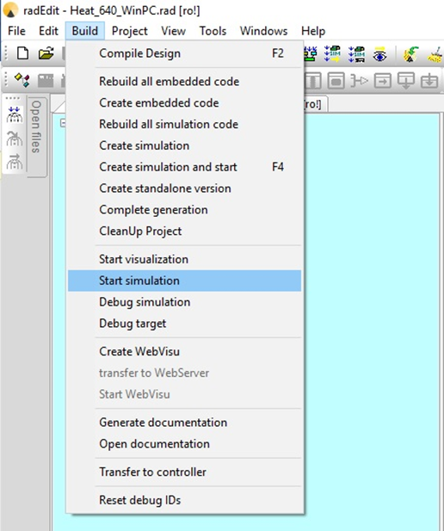

Figure 7‑3, Start of Simulation from Build menu

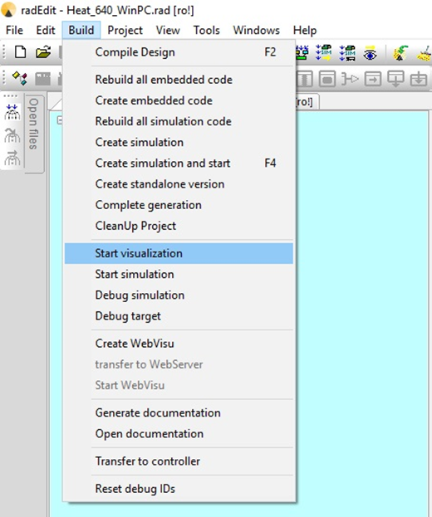

Figure 7‑4, Start of Visualization from Build menu

## Creating standalone Visualization and Simulation applications

It is possible to create a standalone version of the Simulation or Visualization running on computers where no radCASE environment is installed.

To create such standalone applications, follow the instructions reported in section Creation of standalone applications.

Then, Simulation starts by executing the sim.bat file in the Simulation software directory. In the same way, the Visualization starts with the vis.bat file always in the Simulation software directory.

# Creation of standalone applications

## Manual creation

To create a standalone Simulation or Visualization, open the *standalone.bat* file in the develop directory of the project. The name standalone.batis because Simulations and Visualizations are often created for clients.

During the start of the batch file standalone.batit is possible to determine optionally two parameter operations:

1. The first parameter determines the *target path* for the directory with all the necessary files for the Simulation/Visualization.
2. The second parameter copies all the necessary DLLs in the target directory of the Simulation/Visualization.

### Usage of the *standalone.bat* file WITHOUT parameters

The file is started by a double click (e.g. from the Windows-Explorer). A directory *STANDALONE* is created automatically in the project directory (e.g.: C:\Program Files\radCASE\Projects\heating\STANDALONE), which contains all the files for the Visualization/Simulation. The necessary DLLs are NOT contained here. In such case, the **Microsoft Redistributable Packages** has to be installed.

**Example**:

Double click on C:\Program Files\radCASE\Projects\heating\Develop\standalone.bat

### Usage of the *standalone.bat* file WITH parameters

*standalone.bat /t <path> /d*

If only the parameter is indicated with */t*, the target path for the client directory is indicated afterwards, separated by a space.

**Example:**

*standalone.bat /t C:\Client_Project1*

The client directory was named here *Client_Project1*. All files for the Simulation/Visualization are copied in the directory C:\Client_Project1 in the same way as without the parameter. The necessary DLLs are NOT contained in this execution of standalone.bat, as well.

If only the parameter */d* is indicated, the client directory is created in the same way as WITHOUT the parameter. All necessary DLLs are copied in the \STANDALONE directory in this case. The ilenamlation of **Microsoft Redistributable Packages** is not necessary here.

**Example:**

*standalone.bat /d*

If both parameters are used, the target directory is determined where all the files for the Simulation/Visualization and all the necessary DLLs are copied in.

**Example:**

*standalone.bat /t C:\Client_Project1 /d*

In the created directory a license file is required:

Copy therefore the visual.lic file from the \Develop directory into the \win directory under the directory created before by standalone.bat (without parameter: \STANDALONE\win**;** with command line parameter in the defined folder, e.g. with parameters/t C:\Client_Project1 into C:\Client_Project1\win).

## Automatic creation

All the steps described above can be skipped by using the “Create standalone version” command in the radCASE IDE menu (see Figure 8‑1) or according button in the simulation toolbar (see Figure 7‑1, The Simulation toolbar). The standalone.bat will be executed automatically with all the needed parameters and all the needed files will be copied into the automatically created \standalone-folder in the project directory.

 create standalone application

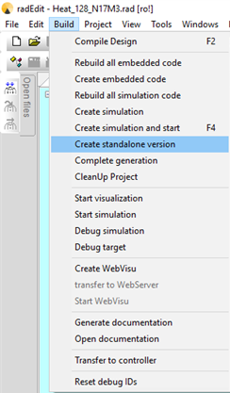

Figure 8‑1, Build Menu – Create standalone version

## Embedding of project specific files in the client index

To copy the project specific files, the batch file standalone_prj.bat in the development directory of the radCASE-Project can be adapted.

**Example:**

*SET TARGET1=%1\bmp*

*copy ..\osdl\imacs_lib\*.bmp %TARGET1%*

*copy ..\osdl\sg_global\*.bmp %TARGET1%*

*copy ..\osdl\sg_global\ctr\*.bmp %TARGET1%*

*copy %osdl_sys%\Lib\global.win\*.bmp %TARGET1%*

*copy %osdl_sys%\Lib\global.ctr\*.bmp %TARGET1%*

*copy %osdl_sys%\Lib\global.ctr\big_bitmaps\*.bmp %TARGET1%*

*copy %osdl_sys%\Lib\wasser.win\*.bmp %TARGET1%*

*copy %osdl_sys%\Lib\elektro.win\*.bmp %TARGET1%*

*copy %osdl_sys%\Lib\digital\*.bmp %TARGET1%*

*copy %osdl_sys%\Lib\analog\*.bmp %TARGET1%*

*copy %osdl_sys%\Lib\mixed\*.bmp %TARGET1%*

The variable TARGET1 gets the target directory from the standalone.batparameter (if necessary). If the standalone_prj.bat file does not exist, standalone.bat is working anyhow. In this case the client directory does not contain the project specific files, which usually cause problems in the Simulation/Visualization execution.

|  |  |
| --- | --- |
|  | Before creating independently operating Visualizations and Simulation, compile these projects without any errors in rad*EDIT*. |

See *Design compilation and Simulation creation* in the Reference Manual.

## Start Simulation/Visualization from command line

The Simulation can be executed from the created client directory through the batch filesim.bat in the\SIM directory.

In the same way Visualization can start from the created client directory through the batch filevis.bat

## Command line parameters

The following command line parameters are available to be passed to *sim.bat/vis.bat*:

|  |  |
| --- | --- |
| **Parameter** | **Description** |
| **/PW=<password>** | Start monitoring with password level identified with given password |
| **/LANG=<langcode>** | Start with selected language; supports the languages which can be selected in the visualization (LV=) |
| **/REC_FILE=<filename>** | Open selected record-file on starting of monitoring |
| **/MAXIMIZED** | Start monitoring with maximized main window |
| **/DIS_SYSKEYS** | Disable system keys/key combinations CTRL+ESC, ALT+TAB, ALT+ESC, ALT+F4, Windows key as long as monitoring is active. |
| **/COMDLL=<DLL parameters>** | Refer to Communication configuration |

Table 11, command line parameters

### Communication configuration

The communication interface can be configured by the command line parameter /COMDLL=<DLL parameters>.

The DLL parameters select and configure the DLL used for communication. If the parameters contain spaces, the parameters must be put in quotation marks (see examples below).

The parameters contain the filename of the communication DLL and an optional configuration. If no configuration is provided the configuration is determined in the order described below. If a configuration is provided the file name and configuration are separated by a colon.

radCASE provides the following communication DLLs:

cclConnection.dll:

By selecting /COMDLL=cclConnection.dll a serial connection is used to connect to the target controller. The configuration contains of multiple parameters separated by a space. If a parameter is not provided a sane standard value will be choosen:

* C<port>: Selects the COM-Port to use. Default value is C1 for COM-Port 1
* B<baudrate>: Selects the baudrate for the connection. Default value is B115200
* D<databits>: Selects the databits for the connection (7 or 8 databits). Default value is D8
* P<parity>: Selects the parity where 0 is no parity, 1 is odd parity and 2 is evenparity. Default value is P0
* S<stopbits>: Selects the stopbits, where 0 is one stopbit, 1, is 1.5 stopbits and 2 is two stopbits. Default value is S0

So a configuration could look like: /COMDLL="cclConnection.dll=C1 B115200 D8 P0 S0"

cclConnectionEth.dll

By selecting /COMDLL=cclConnectionEth.dll an Ethernet connection is used to connect to the target controller. The configuration contains the IP address of the target controller, e.g.: /COMDLL=cclConnectionEth.dll:127.0.0.1

The selected communication interface and configuration can be changed at runtime using the according dialogs. At the start of the project monitor, the communication interface is selected in the following order, using the first provided configuration found.

1. Communication interface selected by command line parameter /COMDLL
2. Communication interface that was active the last time project monitor of the project ran
3. Standard communication interface selected by Timing parameter CD in design
4. Selection dialog
5. No selection (if selection dialog was aborted, no communication interface is selected)

The configuration at start of project monitor is selected in the following order, using the first configuration found:

1. Communication configuration selected by command line parameter /COMDLL
2. Configuration that was active the last time the project monitor used that communication interface (saved separately for every communication interface)
3. Configuration dialog
4. Standard values provided by communication DLL.

# Debugging

In order to debug the application with the Microsoft Visual C++ environment, the steps described in the following sections are required.

|  |  |
| --- | --- |
|  | This description exclusively refers to Microsoft Visual C++ .NET. |

## Select project

First of all the project to be analyzed has to be selected (e.g. ..\Projects\heating).

Afterwards open the file ..\Projectname\Sim\sim.sln by a double clicking the file (see Figure 9‑1).

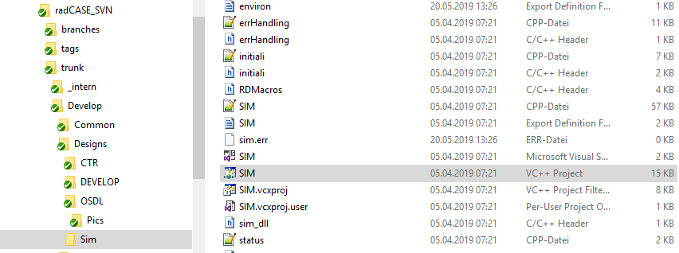

Figure 9‑1, Selection of directory and file

## Microsoft Visual C++ development environment

The Microsoft Visual C++ development environment is opened and the necessary project folder is already downloaded.

Please check that the development environment is set on **Debug.**

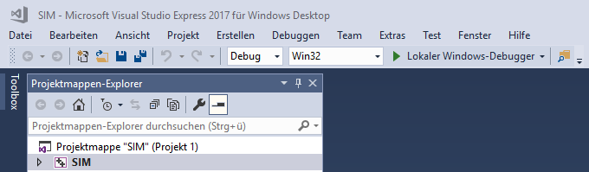

Figure 9‑2, Set Debug

The project tree is in the left area of the development environment. In this section **SIM** has to be selected in order. Then open the context menu with right mouse key and select **Properties**.

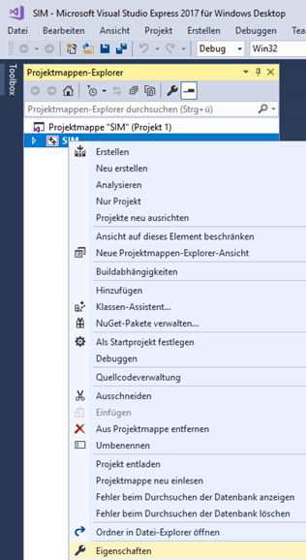

Figure 9‑3, Context menu

## Properties page

Please select **Debugging** in the left sectionof the properties page **(**Explorer section).

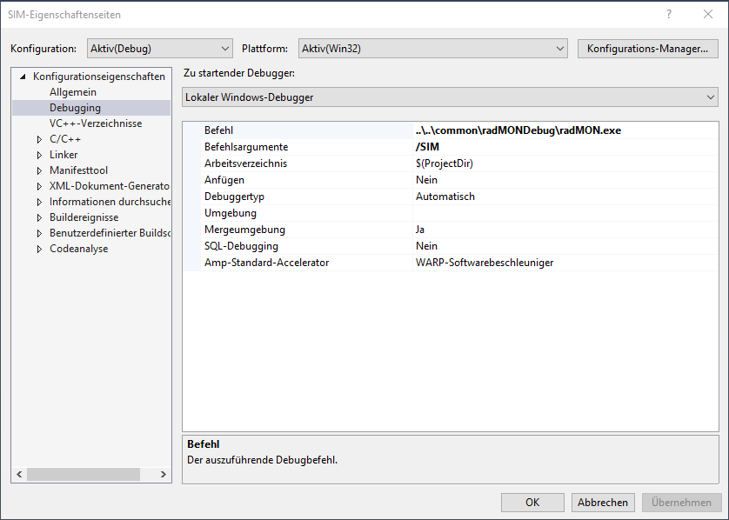

Figure 9‑4, Properties page

### Command

In the **Command** field set the path and the file name of the Common.exe*.*

Then open the input field and select **Browse…**

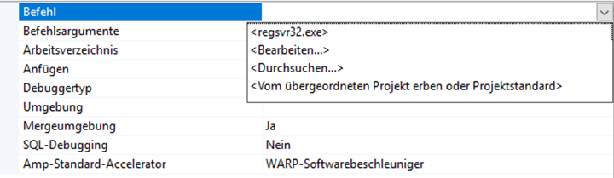

Figure 9‑5, Command

|  |  |
| --- | --- |
|  | Please pay attention that there are a Debug and a Release version of the Common.exefile.  It is absolutely necessary to use the Debug Version! |

**Example**:

*C:\radCASE\Projects\common\debug\Common.exe*

### Command arguments

Please insert **/SIM** in the command arguments field.

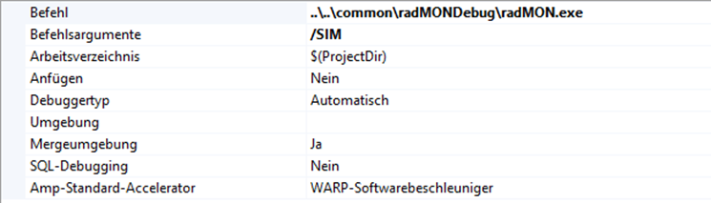

Figure 9‑6, Command matters

The dialog **SIM Property pages** can be closed now by clicking **OK.**

## Debugger operating

A **Debug toolbar** is needed to set breakpoints and to start the debugger.

To add a Debug toolbar put the mouse on the menu bar and right click to open the context menu, then select the option **Debug** (see Figure 9‑7).

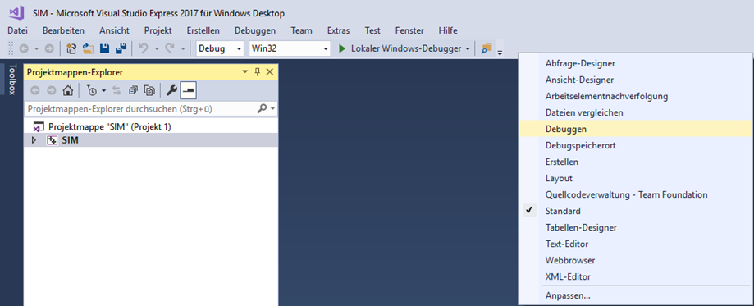

Figure 9‑7, How to add a Debug toolbar



Figure 9‑8, Debug toolbar

By clicking the green arrow the debugger is started.

It may be that the following advice appears:



Figure 9‑9, Report of the Microsoft development environment

The question on Project out of date (see Figure 9‑9) should be answered by clicking **Yes**.

The advice on symbolic information (see Figure 9‑10) has to be answered with **OK**.



Figure 9‑10, Report: no symbolic information for Common.exe

Afterwards the Simulation starts.

To set a breakpoint before the Simulation starts, select a file in the Explorer section on the left.

Open **Source Files** in the **SIM** project folder**.**

Here are the source files that can be analyzed.

The functionality which is assembled by radCASE in a C file is located in module.c.

It can also be that the usercode.c file has to be analyzed.

# Using ITC Interface (Inter Tool Communication)

The inter tool communication interface is an interface for executing Sequence processing in Single step mode from an external application. The interface also provides data exchange to get current values of the elements in the simulation. The interface is meant for automatic testing by providing and executing sequences of data changes and checking the resulting element values.

The communication between the Project monitor and the external application relies on Windows messages (SendMessage/PostMessage). For a communication using windows messages a handle to the windows of the other application is needed. For this the Project monitor has registered the class “radCaseCommon”, which can be found using FindWindow(). The external application has to register a window class with the name “radCheck”.

## Available commands

The following commands are available for the external application to send to the Project monitor:

### Execute single step

By sending the signal WM_USER + 13 to the Project monitor a single step as specified in Single step mode is executed. This message should be send using PostMessage. After execution of the single step the project Monitor will send back the new element values after the step. Refer to Receiving data.

The WPARAM can contain a number. Any number not equal to 0 will select the sequence with the according number. 0 will execute the next step of the current active sequence.

0 will execute the next step of the current active sequence.

### Get current data

By sending the signal WM_USER + 14 the current data of all elements will be requested. This will only cause the project monitor to send back data and not execute any step. (Refer to Receiving data).

### Open a sequence

By sending the signal WM_COPYDATA the external tool can request the project monitor to open a sequence from a file. For this dwData has to be 1, lpData has to contain a Unicode string containing the path and filename of the file, cbData has to contain the size of the string in bytes.

## Receiving data

To send the data from the project monitor to the external tool, the Project monitor will send a message using WM_COPYDATA. Because WM_COPYDATA sends a pointer to local data of the project monitor, this means the project monitor has to wait blocking for the signal to be processed. It is advised to only copy the data and use some kind of signal to process the data in another thread.

The data will have the following format:

4 Bytes: Current timestamp in sequence execution in milliseconds

2 Bytes: Size of IO data

2 Bytes: Size of flag data

2 Bytes: Size of parameter data

2 Bytes: Size of system parameter data

2 Bytes: Size of process data.

After this the data of the blocks follows in the same order like the sizes in the header. The data itself is communicated in the same format as for the Imacs Protocol between target and Project monitor (refer to Imacs-Protocol documentation). Currently communication of string elements is not supported.

A timestamp of -1 means there is currently no sequence active (either no valid sequence was loaded or the last sequence has ended). A time stamp of 0 means a new sequence was loaded).

# Appendix

## Alternative connections between controller device and Visualization

API dependent.

This item is described in a separated manual.

## Simulation and Visualization license

The file visual.lichas to be present in the directory \DEVELOP. This file contains the unblocking to create and execute the Simulation and Visualization. The visual.lic is generated by the model compiler during model compilation and copied to the DEVELOP-directory. It should be ensured, that access rights are given.

For the transfer of the Simulation and Visualization to a third party, the visual.lic file is necessary (refer to ).

## Creation of a modem communication

1. Condition for a modem connection between controller and Visualization PC is an operating connection hardware, i.e. both device and PC need a modem, which can be connected to others via phone device and/or telephone line. The two modems (on the Visualization PC and on the controller) need to have the same baud rate (e.g. 56k Baud).
2. Moreover, the controller, the Visualization PC and the modems have to be switched **ON**.
3. The Visualization software has to be started on the Visualization PC.
4. In **Settings menu** select the correct interface to the modem in the item interfaces.
5. In **Communication menu** select the settings for the connection establishment, like phone numbers and recall function thought the modem item. There it is possible to initiate the connection establishment through the button call as well.

### Modem list

In order to guarantee a steadily operation, it is recommended to use the same modems on both communication sides with a data rate of 56k Baud.

The following modems had been tested successfully for the Visualization:

|  |  |
| --- | --- |
| **Producer** | **Modem type** |
| U.S. Robotics | 3COM U.S. Robotics 56k Voice Faxmodem |
| ELSA | ELSA Microlink 56k Fun |
| ACER | ACER Modem 56k surf |
| COMTIME | SIM – V.92 (Socket-Modem to install) |

Table 12, Supported modem

The following modems are not supported (do not use):

|  |  |
| --- | --- |
| **Producer** | **Modem type** |
| ELSA | ELSA Microlink 56k |

Table 13, Unsupported modem

## Manipulation and initial state

The following tables show the manipulation possibilities as well as the initial state of the elements for the Visualization and Simulation.

### Editing data during Visualization

|  |  |
| --- | --- |
| **AssignType** | **Editability** |
| **AI** | If force mode is activated |
| **AO** | If force mode is activated |
| **DI** | If force mode is activated |
| **DO** | If force mode is activated |
| **TI** | No |
| **CNT** | If force mode is activated |
| **SYS** | No |
| **PAR** | If (Editing mode in VisElem != “without“) |
| **OUT** | No |
| **IN** | Yes |
| **FLAG** | If (Editing mode in VisElem != “without“) (generally only possible if communication Flag) |
| **STAT** | No |
| **PROC** | If (Editing mode in VisElem != “without“) |
| **LOCAL** | If (Editing mode in VisElem != “without“) |
| **KEY** | Yes, is transferred as key operating to the target surface interpreter |

Table 14, Editing data during Visualization

### Editing data during Simulation

|  |  |
| --- | --- |
| **Assigntype** | **Editability** |
| **AI** | If no stimulation equation is present |
| **AO** | If the force mode is activated |
| **DI** | If no stimulation equation is present |
| **DO** | If the force mode is activated |
| **TI** | No |
| **CNT** | No |
| **SYS** | No |
| **PAR** | If (Editing mode in VisElem != “without“) |
| **OUT** | No |
| **IN** | Yes |
| **IO** | Yes |
| **FLAG** | If (Editing mode in VisElem != “without“)  (generally only possible if communication Flag) |
| **STAT** | No |
| **PROC** | If (Editing mode in VisElem != “without“) |
| **LOCAL** | (if Editing mode in VisElem != “without“) |
| **KEY** | Yes, is transferred as key operating to the surface interpreter of the simulated target |

Table 15, Editing data during Simulation

### Initial state of data items

|  |  |  |  |  |  |
| --- | --- | --- | --- | --- | --- |
|  | **Simulation** | | | **Visualization** | |
|  | **Reset**  **(it starts with reset default  values)** | **Restart**  **(it starts as just switched On again)** | **Continue**  **(it continues  simulating as never been swiched Off)** | **(Offline)** | **(Online)** |
| **FLAG** | Standard value | Standard value | Previous value | No value | Current |
| **PROC** | Standard value | Previous value | Previous value | No value | Current |
| **PARAM SYSPAR** | Standard value | Previous value | Previous value | No value | Current |
| **AI, DI** | 0 | Previous value | Previous value | No value | Current |
| **AO, DO** | 0 | 0 | According to Process | No value | Current |
| **TI, CNT (remanent)** | 0 | Previous value | Previous value | No value | Current |
| **TI, CNT (not remanent)** | 0 | 0 | Previous value | No value | Current |
| **LOCAL**  **EVA** | 0 | 0 | Previous value | No value | Current |

Table 16, Initial state of data items

## Database

radCASE uses the open database system NetCDF to memorize the registrations.

Further informations are available on:

<http://www.unidata.ucar.edu/software/netcdf/>

<http://en.wikipedia.org/wiki/NetCDF>

The saving is executed parallel in three different databases, which are managed by a record-file (*.rdf (radCASE data file) or any other customized extension).

|  |  |
| --- | --- |
| <name>.rdf | management record-file |
| <name>_m.nc | database for measured data |
| <name>_p.nc | database for parameter |
| <name>_e.nc | database for event data |

### Customize record-file extension

It is possible to customize the standard extension of the record-file (*.rdf) via config.ini file. Referring to the sim.bat/vis.bat this file can be found at the folder “.\win\config.ini” (if a standalone is used) or at the develop folder. If not already exist, the section [RecordingFile] must be added. The next step is to add the customized extension, which will replace the standard *.rdf extension. At last the description of that customized extension can be added to. Example for adding a xyz extension:

[RecordingFile]

fileExtension=xyz

ilename=XYZ-Customized File

* fileExtension: this will add your new extension, for example “xyz”
* ilename: this will describe your customized extension, for example “XYZ-Customized File”

Using the Open functionality of File Menu (refer to 4.2.1) will result into the following customized open dialog:

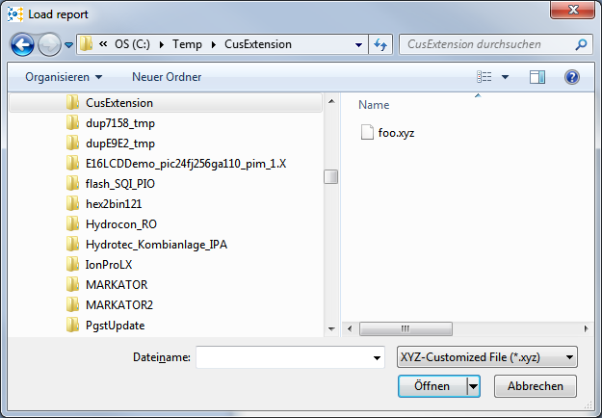

## Window settings of the application

In the develop directory there are the two following files for the window position saving:

|  |  |
| --- | --- |
| **Windowstates.ascii** | Saves the MDI window positions internal to the application.  If this file is deleted the application is only started with the MDI window “mainview“. This is present in the default position. |
| **Windowstates.txt** | Saves the window dimension and the position of the main window in the complete application.  If this file is deleted the application is started with the default dimension of the application main window. |

## Configuration of Ribbonbar

The ribbon bar is configured with a XML-file. This file is located in “<projectdir>\Develop\ProductFrameConf\ProductFrameConf.xml”. All images required for the creation are located in “<projectdir>\Develop\ProductFrameConf\Res”.

To create a custom configuration a custom configuration should be created in directory “<projectdir>\Develop\**Custom**\ProductFrameConf\ProductFrameConf.xml” with all required images in “<projectdir>\Develop\**Custom**\ProductFrameConf\Res”.

The format of the ProductFrameConf.xml is as follows:

<?xml version=”1.0” encoding=”utf-8”?>

<Configuration>

…

</Configuration>

### XML-Nodes

#### Configuration (required)

This node is required and the configuration will not work without it. It is the root node of the configuration. The node is only allowed one time in the configuration.

**Attributes:** none

**Childnodes:** Languages (required), Mainmenu, Categories (required), Timing

#### Languages (required)

Definition of supported languages by configuration, should contain all languages supported by Product Framework. The node is only allowed one time in the configuration.

**Attributes:** none

**Childnodes:** Ln (required)

#### Ln (required)

Definition of one supported language in Configuration.

**Attributes:** none

**Childnodes:** none

**Text:** Abbreviation of one supported language (e.g. UK, GR, …)

#### Mainmenu

Definition of main menu.

Note: It is not possible to define bitmapSmall and bitmapLarge for a main menu, so all icon indizes will refer to a resource within the product framework with the following icons:

Small: 

Large: 

The node is only allowed one time in the configuration.

**Attributes:** name, main_button

**Childnodes:** Category, tooltip, keytip (only attribute popupmenu), item, Exitbutton

#### Exitbutton

Definition of button at the end of main menu. The node is only allowed one time in the configuration.

**Attributes:** name, uid, smallID, bigID, level

**Childnodes:** Panel, tooltip, keytip

#### Categories (required)

Definition of Categories in ribbon bar. The node is only allowed one time in the configuration.

**Attributes:** none

**Childnodes:** Category

#### Category

Definition of one category in the ribbon bar.

**Attributes:** name, bitmapSmall, bitmapLarge

**Childnodes:** name, keytip (only attribute ribelem), Panel

#### Panel

Definition of one panel in a Category.

**Attributes:** name

**Childnodes:** name, Element

#### Element

Definition of an element in a Panel of a ribbon bar, that will trigger an action when clicked on it.

**Attributes:** type, name, uid, smallID, bigID, level, width (only type=”Combobox”), Plugin (only type=”Button”), Action (only if Plugin)

**Childnodes:** name, tooltip, keytip, item (only for type=”Menu” or type=”Combobox”)

#### name

Containing the name of the parent node. Normally this name is shown in the ribbon bar for the element. The node is only allowed one time in parent node.

May contain a static text that is used for all languages. Alternatively for each language defined in Languages (required) a child node may be created. The child nodes tag name is the text specified in Ln (required).

#### tooltip

Containing the tooltip that is displayed when hovering the mouse over the parent node. The node is only allowed one time in parent node.

May contain a static text that is used for all languages. Alternatively for each language defined in Languages (required) a child node may be created. The child nodes tag name is the text specified in Ln (required).

#### keytip

The keytip to access the parent node. The node is only allowed one time in parent node.

Keytips will be displayed when pressing the Alt-key. Then the user can navigate using the shortcuts defined by the keytip.

Note: keytips only work for Elements/items, if the Category/Mainmenu/Element/item above also has a keytip defined.

**Attributes:** ribelem, popupmenu

**Childnodes:** none

#### item

Definition of an item within a Combobox or Menu.

Combobox:

Defines the value of the Combobox

**Attributes:** name

**Childnodes:** name

Menu:

Defines the action taken by a menu entry. Nested menus can be created by nesting items

**Attributes:** name, uid, smallID, bigID, level

**Childnodes:** name, tooltip, keytip, item

#### Timing

Defines plugin functionality for timing based enabling/disabling of Sim/Vis. The node is only allowed one time in the configuration.

**Attributes:** Plugin

**Childnodes:** init

#### init

Defines the plugin functions for initializing timing based enabling/disabling of Sim/Vis. The node is only allowed one time in the configuration.

**Attributes:** isSimEnable, isVisEnable, SIMTime, VISTime

**Childnodes:** none

### XML-Attributes

All values of attributes have to be in quotation marks: <attribute>=”<value>”

#### main_button

Name of bitmap containing icon for button of main menu. Bitmap should be located in res-directory and should have 16x16 pixel.

#### bitmapSmall

Name of bitmap containing small icons for an element. Bitmap should be located in res-directory and have multiple icons within, with each 16x16 pixel

#### bitmapLarge

Name of bitmap containing large icons for an element. Bitmap should be located in res-directory and have multiple icons within, with each 32x32 pixel

#### type

The type of an element.

Possible values are: “Button”, “CheckBox”, “Menu”, “Combobox”

#### name

Contains the name of a node to be used for all languages. This name usually is shown in the ribbon bar. Can be overridden by XML-Tag name

#### uid

Unique ID of functions that will be called as action when clicking on an element. See list of Supported uids

#### smallID

Index of icon within bitmap defined by attribute bitmapSmall in Category or within resource of Mainmenu

#### bigID

Index of icon within bitmap defined by attribute bitmapLarge in Category or within resource of Mainmenu

#### visible

Sets if a view will be opened at startup or not. This only defines the behavior if the application was not started before. If the application was started before this value will be ignored and the application will display all views that were opened the last time

Possible values: 0 – View will not be displayed

1 – View will be shown

#### level

Minimum password level required to see an item.

#### ribelem

Keyboard shortcut for executing functionality.

#### popupmenu

Keyboard shortcut for opening popup menu/submenu

#### width

Width of the combo box

#### Plugin

DLL name containing plugin-functionalities

#### Action

Function name within DLL of Plugin that will be called instead of uid. Function has to be of prototype:

STDAPI function(void);

#### isSimEnable

Function name of function within DLL Plugin that returns if Simulation mode is enabled. The function will be called only once at startup of Product framework and has to be of prototype:

int function(void)

The return value is:

0 – Simulation disabled

1 – Simulation enabled

2 – Simulation with time limit

#### isVisEnable

Function name of function within DLL Plugin that returns if Visualization mode is enabled. The function will be called only once at startup of Product framework and has to be of prototype:

int function(void)

The return value is:

0 – Visualization disabled

1 – Visualization enabled

2 – Visualization with time limit

#### SIMTime

Function name of function within DLL Plugin that returns the time limit of simulation. The function will be called only once at startup of Product framework and has to be of prototype:

Int function(void)

The return value is the seconds that the simulation may be active (-1 for unlimited)

#### VISTime

Function name of function within DLL Plugin that returns the time limit of visualization. The function will be called only once at startup of Product framework and has to be of prototype:

Int function(void)

The return value is the seconds that the visualization may be active (-1 for unlimited)

### Supported uids

Uids only usable in simulation:

|  |  |
| --- | --- |
| uid | Functionality |
| 32853 | Change to visualization mode |
| 108 | Set simulated RTC |
| 5800 | Simulation speed |
| 32806 | Enable/disable single step mode |
| 32807 | Execute single step |
| 310 | Run/Stop single steps |
| 32847 | Open Sequence |
| 32864 | Process Sequence |
| 259 | Close Sequence |

Uids only usable in visualization:

|  |  |
| --- | --- |
| uid | Functionality |
| 32848 | Change to simulation mode |
| 651 | Select Communication Interface |
| 32794 | Configure Communication Interface |
| 32816 | Get protocol from device |
| 32775 | Open modem connection |
| 418 | Activate/deactivate Reduced communication |
| 646 | Open file transfer dialog (see also 4.16) |
| 652 | Open transfer recording dialog (see also Transfer recording) |

Uids usable in both modes:

|  |  |
| --- | --- |
| uid | Functionality |
| 57600 | Creating a new recording |
| 57601 | Opening an existing recording |
| 57603 | Saving recording |
| 57604 | Saving recording as |
| 57607 | Print SURFACE_PRINT of current SURFACE_VIS |
| 57609 | Preview SURFACE_PRINT of current SURFACE_VIS |
| 32771 | Close current recording |
| 57665 | Exit product framework |
| 32810 | ASCII-Export |
| 32858 | Sequence-Export |
| 32860 | Change language of product framework |
| 32801 | Enter password for authorization  Note: this UID can be saved by itself by password but could never be reached again to reset this password |
| 32802 | Reset authorization |
| 32803 | Change passwords for authorization |
| 32836 | Zoom out |
| 32835 | Zoom in |
| 59393 | View hide status bar |
| 150 | View Property view |
| 134 | View Module Tree view |
| 149 | View Output |
| 650 | Freeze Output |
| 32804 | View record panel |
| 32821 | Enable/Disable force mode |
| 1004 | Turn to receive mode |
| 1066 | Turn to playback mode |
| 1065 | Turn to burst mode |
| 32845 | Open Recording settings |
| 32846 | Open event notifier |
| 186 | Open store rate |
| 647 | Enable/disable the “automatic update of parameters” feature (see also 4.7.1) |
| 32812 | Get parameters from device |
| 32813 | Send parameters to device |
| 32814 | Load parameters from file |
| 32815 | Save parameters to file |
| 32822 | Save parameters to ASCII file |
| 417 | Save parameters to binary file |
| 369 | Menu for handling windows. Order or content can’t be changed using items only the names of the items can be changed. The sub-items are “Cascade”, “Tile horizontal”, “Tile vertical” and after that a list of currently opened windows that can’t be modified. This UID can be saved by password and only be hidden completely (and not greyed out). |

## Reduced communication

The data communicated between the target and the PC visualization can be reduced, e.g. for establishing a GSM modem communication.

The following reducing can be done by setting the according value into the [Communication] section of the config.ini file, placed in the Develop directory (or at .\win\config.ini if using standalone):

* Disable communication of display data with **setting** ComDisplay=0
* Disable communication of different IOs with **setting** IOEnable=0x<mask>. 0 means, that all IOs are disabled, the following Bits enable the following IOs:0 means, that all IOs are disabled, the following Bits enable the following IOs:  
  0x01: DOs enabled  
  0x02: DIs enabled  
  0x04: AOs enabled  
  0x08: AIs enabled  
  0x10: CNTs enabled  
  0x20: TIMs enabled
* Disable communication of different Flags. To do this, the Flags have to be assigned to different Communication types V1 – V9 in the design. After this it is selectable which of these Flags will be communicated with **setting** VEnable=0x<mask>. 0 means that no Flags are communicated. By setting the different Bits the different V-Types are communicated:  
  0x01: V1 is communicated  
  0x02: V2 is communicated  
  0x04: V3 is communicated  
  …  
  0x100: V9 is communicated  
  Remember: Only values between 0x00 and 0x1FF are allowed.

Examples of entries in config.ini with maximum reduce of communication:

[Communication]

ComDisplay=0

IOEnable=0

VEnable=0

For an established connection the communication can be switched between the reduced mode and the normal mode. In normal mode all Flags with V1 – V9, all IOs and the display data is communicated (for displays up to 128x64 Pixel). In reduced mode only the items that should be communicated according to previous setting, in the config.ini file, are communicated. To switch between reduced and normal mode a Checkbox or Button with UID 418 has to be added to the product framework (see also 11.7 Configuration of Ribbonbar). The activated setting means reduced communication.

Example of an XML-Node to do this:

<Panel name="ComLevel">

<UK>Comm. reduced data</UK>

<GR>Komm. reduzierte Daten</GR>

<Element type="CheckBox" name="ComLevel" uid="418" smallId="-1" bigId="3">

<name>

<UK>reduced data</UK>

<GR>reduzierte Daten</GR>

<FR>moins dates</FR>

<IT>reduced data set</IT>

</name>

</Element>

</Panel>

This could e.g. be added below the following XML-Node:

<Panel name="VIS">

<Element type="Button" name="VIS" uid="32853" smallId="0" bigId="0"/>

</Panel>

Please remember to make the changes of the example in the ProductFrameConf.xml file of the CUSTOM-Directory.

## Including a file for online help

After the first execution of the Simulation or Visualization (by using respectively the sim.bat or vis.bat batch files) the file config.ini is created in the subdirectory \win. To provide the help function in the standalone version, the file config.ini has to be edited.

Just insert the following line below the marker [GENERAL]:

HELPFILE=MyHelpFile.pdf

Such line makes the Simulation/Visualization open the desired help file (e.g. in this case MyHelpFile.pdf) by clicking on the item Help in the ? entry of the menu. The document MyHelpFile.pdf has to be located in same directory with the file radMON.exe.

If the help file is located in a subdirectory (e.g. help) of the standalone version, just add the relative path (starting from the directory where the radMON.exe is located).

Example:

HELPFILE=help\MyHelpFile.pdf

|  |  |
| --- | --- |
|  | The Help Topics entry of menu will be grayed out as long as no HELPFILE-option is defined in the config.ini file. |